Appendix 2: Puro.earth Standard and Marketplace General Rules

1 General 4
1.1 Puro.earth Standard, Registry and Marketplace 4
1.2 PURPOSE OF THESE RULES 5
1.3 RULES GOVERNANCE 5
1.4 DEFINITIONS 5
1.5 OTHER GENERAL RULES 10
2 Production Facility Registration to the Registry 10
2.1 PROCESS DESCRIPTION 10
2.2 PRODUCTION FACILITY STANDING DATA 12
2.3 MAINTENANCE OF PRODUCTION FACILITY STANDING DATA 12
2.4 DEREGISTRATION FROM THE REGISTRY 12
3 Certificate Transactions in the Registry 13
3.1 CERTIFICATE TRANSACTIONS 13
3.2 CERTIFICATE ISSUING 13
3.3 CERTIFICATE RETIREMENT 14
3.4 CERTIFICATE EXPIRY 15
3.5 CERTIFICATE WITHDRAWAL 15
4 Certificate Transactions in the Marketplace 16
5 Reports from the Registry 19
6 Other Provisions 20
Annex A: Biochar Methodology 21
Annex B: Carbonated Building Element Methodology 33
Annex C: Wooden Building Element Methodology 40
Annex D: List of Issuing Body’s Agents 49
Annex E: Report and Document Templates 50
Annex F: Intentionally left blank 51
Annex G: Geologically Stored Carbon Methodology 52
Document History 62

General

Puro.earth Standard, Registry and Marketplace
    - The aspiration is to create a functioning market for Long-Term CO2 Removal, which is reliable, efficient and location independent. The aim is to generate an incentive for CO2 Removal and to provide companies means to realize their societal value in reversing climate change.

    - CO2 Removal Standard, Registry and Marketplace is a platform for the Issuing, trading and retiring of CO2 Removal Certificates (CORCs). In the System, Production Facilities capable of removing CO2 are registered and audited. CORCs are Issued for volume of Long-Term net CO2 Removal realized over a time period in these Production Facilities. These CORCs are then transferable to other Account Holders. The value of the CORC is realized by Retirement, thereby removing it from circulation and making the Beneficiary of the Retirement the sole owner of the CO2 Removal Attributes.

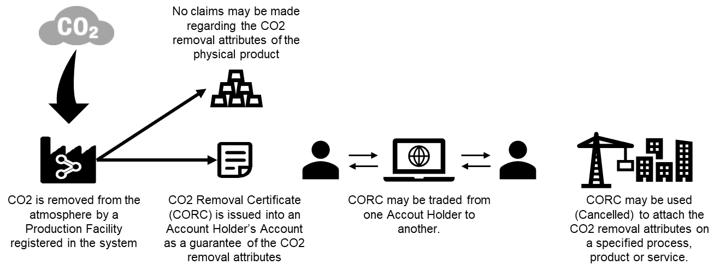

    - All processes aim to exclude the possibility of more than one CORC being Issued for the same volume of CO2 Removal and that the CORC Issued represents the sole proof of ownership of the associated CO2 Removal Attributes.

    - All System participants need to be registered Account Holders of the System and need to have signed the Puro.earth Terms and Conditions.

    - The Registry stores information of the CORCs issued, transferred and retired.

PURPOSE OF THESE RULES

These rules define the roles and responsibilities of different actors in the System and facilitate assessment of contractual compliance. The aim of these rules is to protect the rights of Account Holders of the System and to guarantee equal treatment.

These rules and their annexes define the accepted CO2 Removal Methods and corresponding Methodologies to provide procedures to verify the compliance of CO2 Removal activity for issuing of CORCs

RULES GOVERNANCE
    - These rules are governed by the Advisory Board. The Advisory Board members are selected by the Board of Directors of Puro.earth Oy. Board of Directors approves the terms of reference for the Advisory Board.
    - Changes to these rules are not automatically considered in the order in which they were received but may be prioritized by the chairman of the Advisory Board and any other Advisory Board member in collaboration with the Issuing Body.

DEFINITIONS

1.4.1. DEFINITIONS FOR STANDARD AND REGISTRY
Account – account in the Registry in which CORCs held by Account Holders are stored.
Account Holder – Legal person who has been approved as an Account Holder in the System and who thereby possesses an Account and rights to execute specified Transactions.
Advisory Board – A governing body of these Puro.earth General Rules.
Attribute – Characteristic of CO2 Removal such as production dates, Removal Method and location, which are recorded in the CORC.
Baseline - The production of greenhouse gases that have occurred prior to the introduction of the activity accounted over a time period. This historical data point acts as a counterfactual benchmark to evaluate the success of the activity to remove greenhouse gases.
Beneficiary - A legal person who is named as the benefitting party of the CORC Retirement. The Beneficiary is the sole owner of the Attributes represented by the CORCs, which are Retired for its benefit. Examples of beneficiaries might include, but are not limited to: companies, public entities, private or public organizations.
Biochar - production of which is a Removal Method. CO2 Removal results from the pyrolytic conversion of organic biomass to biochar with high fixed carbon content and long-term chemical and structural stability.
Buffer - A Buffer is used to correct the volume of Output for the purpose of Issuing to account for e.g. metering inaccuracies and product life-time emissions. The Buffer is set by default at 10% for all Removal Methods unless otherwise specified in the relevant Audits or Removal Method Methodology. This means that for every 100 tons of CO2 Removal Output, 90 CORCs are Issued, i.e. Issuance = Output*(100%-Buffer).
Retirement – Retirement of a CORC from circulation by realizing its value and making the Beneficiary of the Retirement the sole owner of the CO2 Removal Attributes.
Retirement Request - A template to be filled by an Account Holder for initiating a Retirement. The request shall have the contents as specified in Annex E.
Carbonated Building Element – production of which is a CO2 Removal Method. CO2 Removal results from the chemical binding of CO2 into the building element during the hardening phase.
Change Request – A proposal for amending these rules.
CO2 Removal – CO2 Removal is achieved by a) absorbing CO2 from or b) preventing its entrance to the atmosphere and converting the CO2 to a stabile storage, which for a Long-Term prevents the CO2 from being released to the atmosphere.
CO2 Removal Supplier - An Account Holder registering a Production Facility capable of CO2 Removal according to the relevant Removal Method specific Methodology.
CORC - CO2 Removal Certificate is an electronic document, which records the Attributes of CO2 Removal from registered Production Facilities. Each CORC represents a volume of 1 ton of Long-Term CO2 Removal.
Country of Origin - The country of location of the Production Facility generating Output for which the CORC was issued.
Environmental and Social Safeguards – Mechanisms to identify, mitigate and prevent averse environmental and social impacts resulting from implementation of Removal Methods.
Expiry – Removal of CORC from circulation due to the cessation of its lifetime.
Issuance – Transaction performed by the Issuing Body to create CORCs based on Output from registered Production Facilities.
Issuance date - The date of Issuance recorded in the CORC.
Issuing Body - The Body responsible for Issuing CORCs, for operating the System and for overseeing the reliability of the System. The Issuing Body of the System is Puro.earth Oy.
Long-Term - Long-Term is defined as minimum length of 50 years.
Methodology – Methodology provides procedures to verify the compliance of CO2 Removal activity with the Removal Method. Methodology provides sound CO2 Removal quantification Methodology specific to each Removal Method. It specifies the activity boundaries, detailed calculation formulas and the proof needed of the activity performance. A Methodology may be revised, and the latest valid version must be used when issuing new certificates.
Output – Volume of CO2 Removal within a certain time period which is eligible to receive CORCs. CORCs are always Issued for net CO2 Removal in the production process, which means that the total volume of Output is determined by subtracting from the CO2 Removal volume the CO2 emissions generated directly or indirectly due to the production process or materials used according to the Removal Method specific Methodology.
Output Report - The CO2 Removal Supplier reports the Output of a Production Facility periodically to the Issuing Body by submitting an Output Report. An Output Report can be generated manually or automatically. The contents of Output Reports are specified in Annex E.
Output Audit – Audit performed by a 3rd party for determining that the volume of CORC Issuance corresponds to the Output of CO2 Removal of that time period from a registered Production Facility according to the Removal Method specific Methodology. In the Audit, CORCs Issued are compared with the reported Output in the Output Report(s) for the same period.
Output Audit Report - A report generated by the Output Auditor based on the Output Audit. The Report shall have the contents as defined in Annex E.
Output Auditor – Independent 3rd party verifier selected by the CO2 Removal Supplier to perform Output Audits. An Output Auditor may be the same body as the Production Facility Auditor. List of Output Auditors accredited by the Issuing Body is available in Annex D.
Production Facility – A facility capable of CO2 Removal according to one or several Removal Method specific Methodologies.
Production Facility Audit – Audit performed by a 3rd party to verify the details and eligibility of a Production Facility to be approved into the System according to the relevant Removal Method specific Methodology.
Production Facility Audit Report - A report generated by the Production Facility Auditor based on the Production Facility Audit. The Report shall have the contents as defined in Annex E.
Production Facility Audit Statement - A statement published by the Issuing Body with regard to the outcome of a Production Facility Audit. The Statement shall have the contents as defined in Annex E.
Production Facility Auditor – Independent 3rd party verifier selected by the CO2 Removal Supplier to perform Production Facility Audits. A Production Facility Auditor may be the same body as the Output Auditor. List of Production Facility Auditors accredited by the Issuing Body is available in Annex D.
Production Facility Registration Form - A template to be filled by a CO2 Removal Supplier for initiating a Production Facility registration process. The form shall have the contents as specified in Annex E.
Puro.earth Standard – Standard defining the eligibility requirements for CO2 Removal Suppliers and quantification rules for the number of CORCs to be issued
Puro.earth Terms and Conditions - A contract made between the Issuing Body and the Account Holder for joining the Standard and Registry System.
Registry - The electronic database of the System in which CORCs are deposited and transacted.
Registry Operator - Body responsible for the technical operation of the Registry. The Registry Operator of the System is Puro.earth Oy. The registry is operated on an electronic database provided by Grexel Systems Oyj.
Removal Method – Method for a) absorbing CO2 from or b) preventing its entrance to the atmosphere and keeping it stored for a Long-Term. Removal Methods include capture, conversion of CO2 to a stabile format, and the Long-Term storage. List of approved Removal Methods is available in Annexes A, B and C.
System – CO2 Removal Certificate (CORC) system provided by the Issuing Body and the Marketplace Operator.
Transaction – Processing of CORCs in the Registry database. Transactions include Issuance, Transfer, Retirement, Expiry and Withdrawal.
Transfer – The transfer of CORC from one Account Holder to another
Transfer Request – A request made by an Account Holder to the Issuing Body to Transfer CORCs to another Account Holder.
Underlying Product - The physical product the production of which a) removes CO2 from prevents its entrance to the atmosphere and b) is the basis for Issuing CORCs.
Wooden Building Element – production of which is a Removal Method. CO2 Removal results from the wooden building elements storing the carbon captured by trees. The CO2 removal is considered long-term, when used in construction of buildings.

1.4.2. DEFINITIONS FOR MARKETPLACE
Auction – An auction for CORCs facilitated by the Marketplace Operator and where Account Holders may execute CORC trading by placing and selecting Bids.
Auction Closing Time - Time announced by the Marketplace Operator before which all CORC Bids must be placed and selected in an Auction.
Cap Price – The maximum price for which the Account Holder is willing to purchase a specific set of CORCs from the Auction.
Retirement Purchase – A type of Transaction where any actor, whether or not an Account Holder, may purchase and immediately retire CORCs to its own or another actor’s benefit.
Certificate Listing Service – A service facilitated by the Marketplace Operator, which lists CORCs made available for Retirement Purchase, or Service Provider Trade.
Marketplace - The electronic software system in which the Marketplace transactions are performed.
Platform Agreement – A contract made between the Marketplace operator and the Account Holder.
Marketplace Operator - Body responsible for the technical operation of the trading, purchase and Auction System. The Marketplace Operator is Puro.earth Oy. The Marketplace Operator may also be referred to as the Service Provider.
Marketplace Transaction – Transactions in marketplace include Certificate Purchase, Transfer Request, Retirement Request, Service Provider Trade.
Optional Criteria - Additional criteria on Removal Method and Country of Origin of the CORC, which may be associated with a CORC Purchase.
Pay-as-Bid Auction – An auction mechanism where multiple homogeneous products are sold at different prices.
Pre-Purchase Agreement – a bilateral agreement between two Account Holders made known to Marketplace Operator by one of the agreement parties or their representative.
Pre-Purchase Agreement Identifier – A unique identifier of a Pre-Purchase Agreement assigned by Marketplace Operator when a Pre-purchase Agreement is made known to Marketplace Operator.
Purchase Bid - A bid for purchasing CORCs from the Auction with a set Cap Price, Volume and where applicable, Optional Criteria.
Service Provider Trade – A type of Transaction where the Service Provider acts as a counterparty in the trade between the buyer and the Account Holder acting as the seller.
Trade Value – The total monetary value of a trade of CORCs between the Account Holder acting in the role of seller and Account Holder acting in the role of buyer. Trade Value = Trade Volume * Trade Price per CORC.
Trade Volume - The total number of CORCs included in a trade between the Account Holder acting in the role of seller and Account Holder acting in the role of buyer.

OTHER GENERAL RULES
1.5.1. The Issuing Body is responsible for retention of all records for a minimum of 5 years in the past.
1.5.2 The Issuing Body is responsible through contractual and other means to ensure that no volume of Output is duplicated in the Issuance or Auctioning process and that the Retirement of CORCs represents the sole ownership of the CO2 Removal Attributes.
1.5.3. The Issuing Body has the right to perform ad-hoc audits concerning the Retirement and associated claims made by Account Holders to ensure that CORCs are used according to the principles set out in these rules.
1.5.4. The terms with a capitalized first letter which are used in these rules shall have the meanings respectively ascribed to them in the Definitions chapter.

Production Facility Registration to the Registry

PROCESS DESCRIPTION

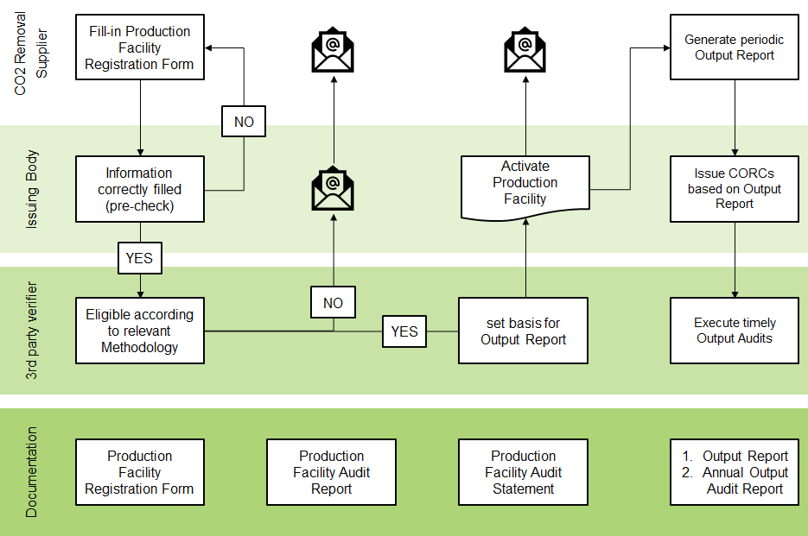
2.1.1. Production Facility registration is initiated by the CO2 Removal Supplier by filling in Production Facility details in the Production Facility Registration Form. Once all information is recorded, the CO2 Removal Supplier submits the Production Facility for approval by the Issuing Body. The CO2 Removal Supplier must also include information proving its right as the owner of the Production Facility to register the Production Facility.
- In case the CO2 Removal Supplier is not the (sole) owner of the Production Facility, it must include a power of attorney signed by all the (other) owner(s) of the Production Facility with an ownership share, which is higher than 10%. This power of attorney shall accredit the CO2 Removal Supplier the right to register the Production Facility in the System.
2.1.2. CO2 Removal Supplier shall be able to demonstrate Environmental and Social Safeguards and that the Production Facility activities do no significant harm to the surrounding natural environment or local communities. This may be done through one or several of the following:

- Environmental Impact Assessment (EIA)
- Environmental permit
- Other documentation approved by the Issuing Body on the analysis and management of the environmental and social impacts
- When applicable, the Production Facility activities shall be developed with informed consent from local communities and other affected stakeholders and have a policy in place to address potential grievances

2.1.3. CO2 Removal Supplier shall be able to demonstrate additionality, meaning that the project must convincingly demonstrate that the CO2 removals are a result of carbon finance. Even with substantial non-carbon finance support, projects can be additional if investment is required, risk is present, and/or human capital must be developed. To demonstrate additionality, CO2 removal Supplier must provide full project financials and counterfactual analysis based on Baselines that shall be project-specific, conservative and periodically updated. Suppliers must also show that the project is not required by existing laws, regulations, or other binding obligations.
2.1.3. Within 2 weeks from the submission of the Production Facility for approval, the Issuing Body ensures that the Production Facility data is correctly filled.
- In case the application or documentation on additionality, Environmental and Social Safeguards needs to be amended, the Issuing Body requests the CO2 Removal Supplier to fill in the relevant data.
- The Issuing Body may also deem that the Production Facility is not eligible for the System in case it cannot generate Output according to any of the Removal Method specific Methodologies.
2.1.4. Where a Production Facility registration is approved by the Issuing Body, it then undergoes a 3rd party verification (Production Facility Audit) by a Production Facility Auditor who assesses the eligibility of the Production Facility for additionality, Environmental and Social Safeguards and one or several Removal Methods according to the relevant Methodology. The Production Facility Audit also sets the basis for the Output Report.
- In case the verification is passed the Production Facility Auditor informs the Issuing Body and the CO2 Removal Supplier of the successful result by submitting the Audit Report and Statement.
- In case the verification is not passed, the Production Facility Auditor informs the Issuing Body and the CO2 Removal Supplier of the failure and the reasons thereof along with the Audit Report.
2.1.5. Where a Production Facility registration is approved by both the Issuing Body and the Production Facility Auditor, the Issuing Body activates the Production Facility in the Registry and its Output becomes eligible to receive CORCs.

PRODUCTION FACILITY STANDING DATA
2.2.1 Each registered Production Facility includes the following information:
- Facility unique identifier;
- CO2 Removal Supplier registering the Production Facility;
- Name;
- Location;
- Date on which the Production Facility became eligible to receive CORCs;
- Volume of Output during the full calendar year prior to registration;
- Removal Method(s) for which the plant is eligible to receive CORCs;
- Whether the Production Facility has benefited from public support; and
- + Removal Method specific information as may be specified in the relevant Removal Method specific Methodology.

MAINTENANCE OF PRODUCTION FACILITY STANDING DATA
2.3.1. CO2 Removal Supplier is responsible for informing the Issuing Body without any delay on changes, which have resulted in the registered Production Facility standing data becoming inaccurate and which might impact the Attributes of Issued CORCs compromise Social and Environmental Safeguards. Due to the information changes a new Production Facility Audit needs to be performed.
2.3.2. The Issuing Body has the right to commission an accredited 3rd party verifier preferably different from the previous Production Facility Auditor, to perform an ad-hoc Production Facility Audit and Output Audits. The CO2 Removal Supplier is in such case responsible for providing the Production Facility Auditor with documentation and access rights necessary to perform the Audit.
2.3.3. The Production Facility registration is valid for up to 5 years. The validity may be extended by 5 years (and then on every 5 years) by performing a new Production Facility Audit.

DEREGISTRATION FROM THE REGISTRY
2.4.1. Where a CO2 Removal Supplier seeks to deregister a Production Facility from the System it may do so by notifying this to the Issuing Body. The deregistration is activated within a month from the receipt of this information by the Issuing Body. In such case, the CO2 Removal Supplier is responsible for any Production Facility fees still due.

Certificate Transactions in the Registry

CERTIFICATE TRANSACTIONS

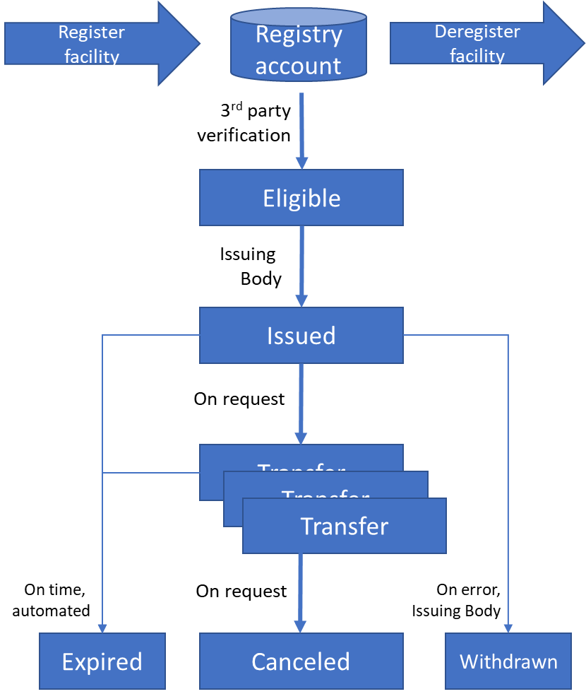

CERTIFICATE ISSUING
3.2.1. The Issuing process eliminates the possibility of Issuing more than one CORC for the same Output.
3.2.2. CORCs are Issued based on an Output Report from the CO2 Removal Supplier for a specified time period and produced in a Production Facility registered in the System.
A CO2 Removal Certificate CORC represents a volume of 1 (one) ton of CO2 Removal. Each CORC shall specify the following Attributes:
- Certificate Unique identifier;
- Issuance date;
- Country of Issue;
- Removal Method;
- Facility Identity, Name and Location of the Production Facility;
- the start and end dates of Output;
- date on which the Production Facility became eligible to receive CORCs;
- whether the Production Facility has benefitted from public support; and
- Removal Method specific information as may be specified in the corresponding Methodology.

3.2.3. CORCs are always Issued for net CO2 Removal in the production process, which means that the total volume of Output is determined by subtracting from the CO2 Removal volume the CO2 emissions generated directly or indirectly due to the production process or materials used according to the Removal Method specific Methodology.
3.2.4. CORCs are always issued for project activities that are additional, meaning that the project must convincingly demonstrate that the CO2 removals are a result of carbon finance. Suppliers must also show that the project is not required by existing laws, regulations, or other binding obligations.
3.2.5. CORCs may be Issued for Output, which at the time of Issuing has
i) not been sold in the form of or associated with the Underlying Product; and
ii) taken place maximum of 18 months in the past,
from Production Facilities registered. This may include time periods when the Production Facility was not registered into the System as long as the Output of that period may be verified according to the relevant Removal Method specific Methodology and the Environmental and Social Safeguards.
3.2.6. To initiate the Issuance process, a CO2 Removal Supplier with a registered Production Facility sends an Output Report to the Issuing Body annually, quarterly or monthly. Issuing Body checks that the Production Facility Audit is valid and issues the amount of CORCs corresponding to the CO2 Removal volume in the Output Report corrected with the Buffer to the CO2 Removal Supplier’s Account.
3.2.7. Any leftover, representing a volume less than 1 ton, is stored and added into the Output volume of the following Issuance.
3.2.8. Once a CORC is Issued no claims may be associated for the Underlying Product, that overlap with the Attributes represented by the CORC. This provision dictates that the Underlying Product for which the CORC was Issued shall not be associated with any claims of CO2 Removal nor other Attributes represented by the CORC.
3.2.9. An Output Audit is done by a 3rd party Output Auditor annually against the Output Reports for past 12 months and the Removal Method specific Methodology. Required proofs and evidence, which define the Output of CO2 Removal that has taken place and that the CO2 Removal is Long-Term, are specified in the Removal Method specific Methodology.
i) In case the Output Audit finds that too many CORCs have been Issued, the Issuing Body shall be entitled to withdraw the corresponding amount of CORCs from the CO2 Removal Supplier’s Account. Where these CORCs are no longer in the CO2 Removal Supplier’s Account, the Issuing Body shall Withdraw the corresponding amount of other CORCs, which are of similar financial value to ensure that no unjust enrichment occurs.
ii) In case the Output Audit finds that too few CORCs have been Issued, the Issuing Body shall Issue the corresponding amount of CORCs to the CO2 Removal Supplier’s Account.

3.3 CERTIFICATE RETIREMENT
3.3.1. Retirement is used to prove that the amount of CO2 corresponding to the volume of retired CORCs has been removed and that the Retirement entitles for exclusive ownership of the quantity and other Attributes of the CO2 Removal.
3.3.2. Account Holders may retire CORCs for their own or another Beneficiary’s benefit. In case the CORC has not been traded via the Marketplace, the Beneficiary must be named as the Account Holder executing the Retirement.
3.3.3. Account Holder or the Marketplace authorized by the Account Holder initiates the Retirement by filling in a Retirement Request and submitting it to the Issuing Body. The Retirement Request shall specify the specific set(s) of CORCs to be Retired along with the following Retirement information:
- Beneficiary name
- Beneficiary Country
- Use purpose (e.g. Brand name, corporate reporting)
- Use time period

3.3.4. The Issuing Body may either approve or reject the Retirement Request.
- In case the Retirement Request is approved, the CORCs are Retired by the Issuing Body and removed from circulation
- In case the Retirement Request is rejected, the Issuing Body informs the Account Holder of the reasons thereof.

3.4 CERTIFICATE EXPIRY
3.4.1. Expiry is the removal of CORC from circulation due to the cessation of its lifetime. CORCs Expire 5 years after the Issuance date.

3.5 CERTIFICATE WITHDRAWAL
3.5.1. For the purpose of maintaining the accuracy and veracity of the System, the Issuing Body has the right to withdraw CORCs from an Account Holder’s Account in case:
- An error has occurred in the Issuing, transferring or other processing of the CORC;
- Due to a Material Breach of the Puro.earth Terms and Conditions.

3.5.2. The Issuing Body is entitled to alter the details of CORCs so as to rectify any errors that have occurred in the Issuance or Transfer process provided that the Account Holder who currently possesses the corresponding CORCs in its Account has agreed to the alteration and that the alteration doesn’t result in any unjust enrichment.

Certificate Transactions in the Marketplace

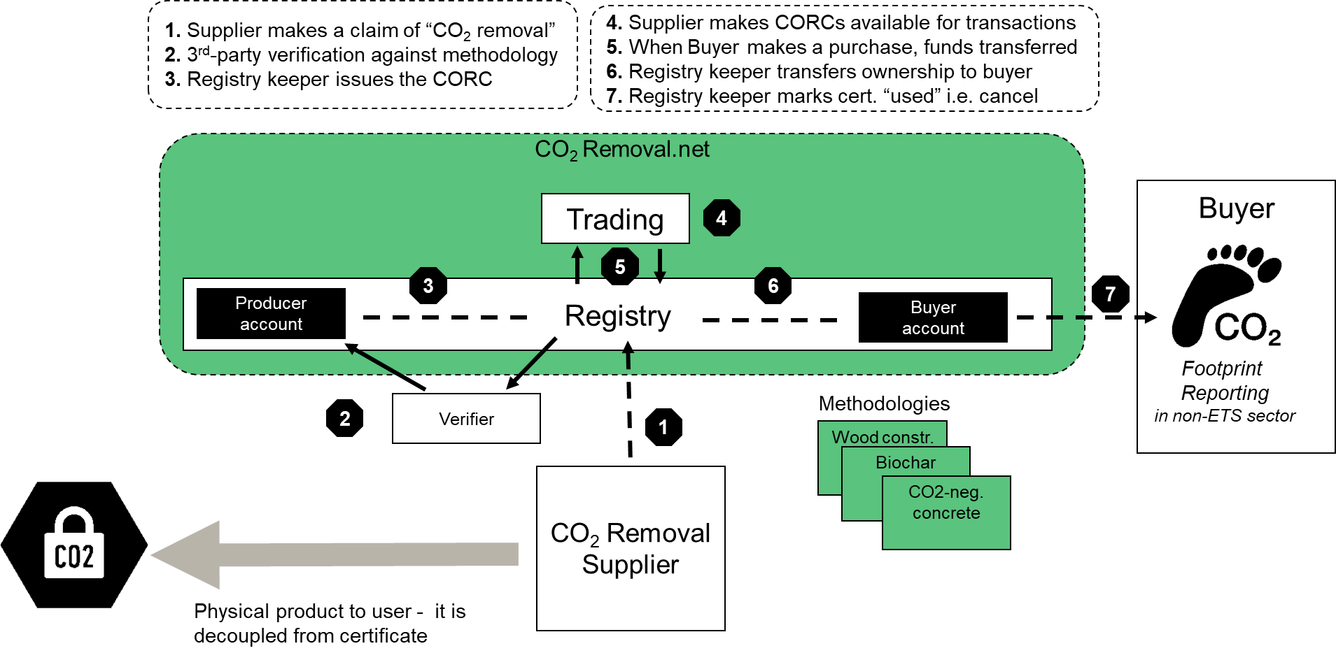

CERTIFICATE AUCTIONING
4.1.1. Issued CORCs may be traded via the Auction. CORC trading is settled using a Pay-as-Bid Principle.
4.1.2. Any CORC placed for sale in the Auction must be Issued no more than 15 months prior to the Auction Closing Time.
4.1.3. The Auction opens 96 hours before the Auction Closing Time. The auction process consists of four 24 hour phases as described in the illustration below. 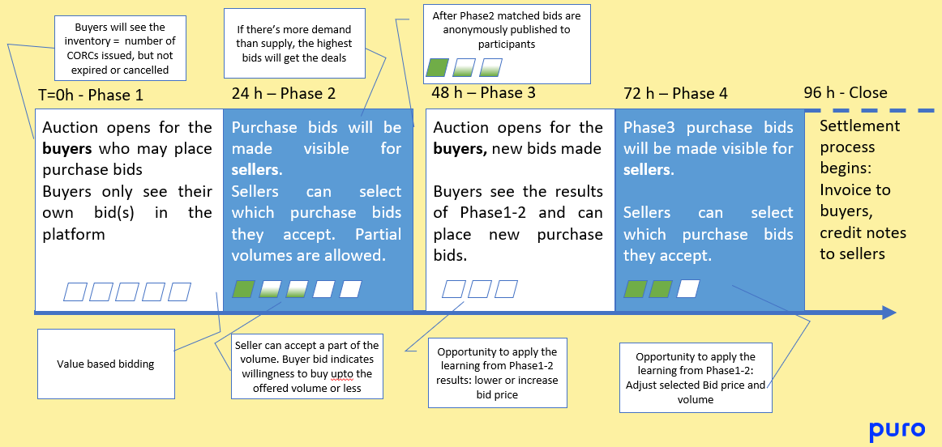
4.1.4. In Phase 1, Account Holders who aim to buy CORCs in the Auction, place Purchase Bids with specific volume and Cap Price. Purchase Bids may also include Optional Criteria on Removal Method and Country of Origin of the CORC.
4.1.5. In phase 2, Account Holders who aim to sell CORCs in the Auction, select the Purchase Bids they want to fulfill. By selecting and confirming a Purchase Bid, the Account Holder commits to sell CORCs with the price specified in the Purchase Bid. Account Holder aiming to sell can choose whether to fulfill the Purchase Bid volume completely or partially.
4.1.6. After phase 2, the matched bids will be anonymously published to Account Holders participating in the Auction.
4.1.7. Phase 3 and 4 are same as Phases 1 and 2, respectively. No bids are carried over from Phases 1 and 2.
4.1.8. The amount of collateral needed to place a Bid is 0€.
4.1.9. Purchase Bids with Optional Criteria can only be selected by Account Holders aiming to sell CORCs if they have CORCs with the required Optional Criteria in their account at the time of the Auction.
4.1.10 Buyers are able to modify or delete already placed Purchase Bids at any time during Phase 1 and 3 of the Auction.
4.1.11. After Auction Closing, the Issuing Body executes the settling process and transfers CORCs between the Accounts of selling and buying Account Holders according to the outcome of the settlement process.

CERTIFICATE SERVICE PROVIDER PURCHASE
4.2.1. An actor, whether an Account Holder or not, may purchase CORCs directly through the Certificate Listing Service provided by the Marketplace. Pre-requirement for Service Provider Trade is that the buyer has signed Puro Platform Agreement or entered into the General Rules, and that the seller has signed a sales authorization agreement to enable Puro.earth to act as the counterparty in the trade.

4.2.2. Puro.earth is a counterparty in the Service Provider Trade and thus reserves the right in its sole discretion to either accept or decline the transaction. In the case of a Service Provider Trade, the Service Provider is not liable for the conclusion of the trade in the event either the buyer or the seller does not fulfill the transaction. For the avoidance of doubt, in the event a Buyer failure the CORCs affected will be unlocked and made available for sale to other Buyers.

4.2.3 The price of CORCs is determined by the selling Account Holder or as a result of a negotiation.

4.2.4. Subsequent to a successful Service Provider Trade and payment thereof, the Issuing Body Transfers the relevant CORCs to the buying Account Holder’s Account or retires them according to the retirement request within two [2] business days from the payment.

4.2.5. Service Provider Trade are executed outside of the Auctions and may not be initiated during the Auctions or three [3] hours before or after the 96 hour period when the Auction is open.

4.2.6. CORCs for Service Provider Trade are selected from the nominated CORC Accounts of Account Holders who have authorized the Issuing Body to sell CORCs through Direct Purchase on their behalf.

4.2.7. CORCs allocated for each Service Provider Trade are selected in the order of the Issuing Date, starting from the earliest. The CORCs allocated for Service Provider Trade are transferred to a separate certificate Account of the authorizing Account Holder and are not simultaneously available for sale in the Marketplace.

4.2.8. Service Provider Trade are not visible publicly or to other Account Holders of the CO2 Removal marketplace apart from the Reports from the Marketplace defined in section 4.6. and Reports from the Registry defined in section 5.

CERTIFICATE PRE-PURCHASE
4.3.1. Two Account Holders may make a bilateral Pre-Purchase Agreement of CORCs and make it known to the Issuing Body by sending a copy of the mutually signed Pre-Purchase Agreement by one of the agreement parties or their representative to contacts@puro.earth unless otherwise instructed.
4.3.2. Marketplace assigns a unique Pre-Purchase Agreement Identifier to the Pre-Purchase Agreement.
4.3.3. The selling Account Holder takes on to ensure that CORCs for the Pre-Purchase Agreement are available in its Account at the time when the Transfer of CORCs in relation to a Pre-Purchase Agreement is due. For this purpose, the selling Account Holder may request the Issuing Body to store such CORCs in a separate Account or transfer them to their own subaccount.
4.3.4. When the Issuing Body receives a Transfer Request in relation to a Pre-Purchase Agreement from the selling Account Holder, the Issuing Body transfers CORCs between the Accounts of the selling and buying Account Holders as agreed in the Pre-Purchase Agreement
4.3.5. CORCs for Pre-Purchase transactions are selected in the order of the Issuing Date, starting from the earliest.
4.3.6. Pre-Purchase transactions are not visible publicly or to other Account Holders of the CO2 Removal marketplace apart from the Reports from the Marketplace defined in section 4.6. and Reports from the Registry defined in section 5.

4.4 CERTIFICATE ONLINE PURCHASE
4.4.1. Any actor, whether or not an Account Holder, may purchase and immediately retire CORCs through the Certificate Listing Service to its own or another actor’s benefit by Retirement Purchase.

4.4.2 To initiate a Retirement Purchase, the actor selects the type and amount of CORCs it seeks to buy from the Marketplace online shop service as well as fills in payment, purpose of retirement and other required information.

4.4.3 The price of CORCs for Retirement Purchase is determined by the selling Account Holder and is made visible to the buyer when selecting the CORCs for the Retirement Purchase.

4.4.4. Minimum and maximum limits for the amount of CORCs that can be included in a single Retirement Purchase transaction are set by the Marketplace.

4.4.5. Subsequent to a successful Retirement Purchase and payment thereof, the Issuing Body retires the requested amount according to the retirement request of CORCs and Marketplace delivers a Retirement Statement for the actor within two [2] office days from the payment.

4.4.6. Retirement Purchase transactions are executed outside of the Auctions and may not be initiated during the Auctions or three [3] hours before or after the 96 hour period when the Auction is open.

4.4.7. CORCs for Retirement Purchase transactions are selected from nominated CORC Accounts of Account Holders who have authorized the Marketplace to sell CORC through Retirement Purchase on their behalf

4.4.8. CORCs requested for each Retirement Purchase transaction are selected in the order of the Issuing Date, starting from the earliest.

4.4.9. Retirement Purchase transactions are not visible publicly or to other Account Holders of the CO2 Removal marketplace apart from the Reports from the Marketplace defined in section 4.6. and Reports from the Registry defined in section 5.

4.5 SALE OF CORC IN EXTERNAL MARKETPLACES
4.5.1. Account Holders in the CO2 Removal marketplace may, through a separate sale authorization, place CORCs for sale in external marketplaces. The CORCs allocated for such purpose are transferred to a separate certificate Account of the authorizing Account Holder and are not simultaneously available for sale in the Marketplace.

4.5.2. Where CORCs are sold in external marketplace, the Marketplace Operator requests Transfer of the relevant CORCs to separate Account and makes the necessary subsequent Transfer or Retirement requests.

4.6 REPORTS FROM THE MARKETPLACE
4.6.1 Reports published by the Marketplace Operator
- The Service Provider may publish an Auction results report, with volumes and volume-weighted average prices of traded CORCs. The Auction results report is made publicly available after each Auction.
- The Service Provider may publish a Reference Price Index that can be published on its website and / or other media.
- The Marketplace does not publish information which would reveal data on individual trades.

4.6.2 Reports available on request from the Marketplace Operator
- Auction results for the requesting Account Holder

5 Reports from the Registry
5.1. Reports published by the Issuing Body:
- Audit Statement for Production Facilities. Detailed Audit Report is not publicly available.
- Searchable database of issuances and retirements with details about the Beneficiary and the Production Facility of the CO2 Removal Supplier. The data is updated on daily basis. The Beneficiary can request a reasonable time delay, no longer than 12 months, in publishing Beneficiary details.
5.2. Reports available at request from the Registry Operator:
- Account Statement of the Account(s) owned by the requesting Account Holder
- Retirement Statement, which includes the details of the Retirement Transaction as well as the CORCs included.

6 Other Provisions
6.1. Account Holder is subject to these rules once the Application has been approved until the Resignation or Expulsion.
6.3. In the future, it might be possible to include a new type of certificate which doesn’t comply with the CO2 Removal longevity requirement of the current CORC. In such case, the process is called delaying of CO2 emissions rather than removal.
6.4. CO₂ Removal Supplier of the marketplace aims to invest the income of sales of CORCs to the growth of the production volume.

6.5. Unless otherwise instructed CORCs are always selected for Transfer starting from the CORC with the earliest Issuance Date fulfilling the required characteristics and Optional Criteria.

6.6. All Transactions are subject to Service Fees as defined in the Appendix 5 of Platform Agreement. Where the buyer is not an Account Holder, the service fee of the Transaction for the buyer is stated at the marketplace.

Annex A: Biochar Methodology

This methodology quantifies the net CO₂ Removal achieved over the time horizon of 100 years by the production of biochar, when used in applications placed in the environment.

CO₂ Removal results from the conversion of biomass to biochar with long-term chemical and biological stability, i.e. high resistance to degradation process when placed in the environment. Carbon captured in biomass by photosynthesis is stabilised in biochar and return to the atmosphere delayed by orders of magnitude compared to parent biomass.

This methodology is applicable to certificates issued for the CO₂ Removal Marketplace.

1 Eligible activity type

An eligible activity is an activity capable of producing as output biochar with long-term stability. CO₂ Removal results from organic biomass being heated with no or limited supply of oxygen, such as pyrolysis or gasification processes. The pyrolysis gases must undergo engineered emissions control to decrease methane to negligible levels.
In such processes, the biomass undergoes a carbonization reaction forming solid biochar. Biochar is a material in which the carbon atoms have bonds stronger than those found in the parent biomass, and is therefore resistant to biotic and abiotic degradation processes when placed in the environment.

Biochar stability can be estimated from biochar properties, specifically the molar hydrogen to organic carbon ratio ($H/{C_{org}}$)$.$ Material with an ($H/{C_{org}}$) ratio lower than 0.2 is characterized as being hardly degradable in the environment.

The eligibility of the biochar production activity is determined in the Production Facility Audit.

Requirements for activities to be eligible under the methodology

1.1.1. Use of biochar in applications placed in the environment (e.g. greenhouse substrates, surface water barrier, animal feed additive, wastewater treatment, insulation material, landfill/mine absorber, soil additive). Biochar sequesters carbon over centennial timescales, when not used as fuel or reductant. Therefore, its energy and reductant use is excluded, and all other uses are eligible.

1.1.2. Biochar needs to be produced from sustainable biomass: sustainably sourced biomass, or waste biomass such as agricultural waste, biodegradable waste, urban wood waste or food waste. A list of biomass types can be found in IPCC Appendix 4 Method for Estimating the Change in Mineral Soil Organic Carbon Stocks from Biochar Amendments (Table 4AP.1) and the positive list of biomass feedstock of the European Biochar Certificate.
- In case of agricultural waste sustainable collection means that 30% of residues are left to the field to avoid decreasing soil health and crop levels.
- Timber that has been damaged by a natural disaster (e.g. fire, pests, flood) and cannot be economically recovered or used as originally intended
- Use of invasive species, meaning plants that are not native to the region of activity and are causing environmental harm, are eligible biomass for biochar activity when following requirements are met: i) the species to be cleared are recognized by an appropriate state or national authorities and ii) the carbonization of the cleared waste is not mandated or legally required by relevant authorities and iii) the CO2 removal Supplier has procedures in place to differentiate the invasive species from other local species, and to avoid unintended clearing of existing native vegetation within the project area

1.1.3. The producer must demonstrate net-negativity with results from a life cycle assessment (LCA) or carbon footprint of the biomass production and supply, the biochar production process, and of the biochar use, including disaggregated information on the emissions arising at different stages. Life cycle assessment (LCA) shall present carbon footprint cradle-to-grave according to ISO standard or WRI GHG protocol.

1.1.4. The direct use of fossil fuels for heating the pyrolysis reactor is prohibited, unless only used for ignition/pre-heating or in a mobile unit and the emissions are fully included in the LCA. The use of waste heat from other industrial processes, such as bio-digesters or cement production is permitted.

1.1.5. In the biochar production process, the pyrolysis gases must be combusted or recovered through an engineered process that either negates or makes negligible any methane emissions to the atmosphere. Bio-oil and pyrolysis gases can be stored for later use as renewable energy or materials.

1.1.6. The molar${ H}/{C_{org}}$ ratio must be less than 0.7. The${ H}/{C_{org}}$ ratio is an indicator of the degree of carbonization and therefore of the biochar stability. Values exceeding 0.7 are an indication of non-pyrolytic chars or pyrolysis deficiencies.

1.1.7. Measures have to be taken for ensuring safe working environment and safe handling and transport of biochar to prevent fire and dust hazards. Such safety measures are, but not limited to, providing a Material Safety Data Sheet, laboratory test results from UN test N.4, using a steam activation process or by other means ensuring that the biochar is sufficiently covered, moist and cool during transport and handling.

1.1.8. The eligibility of the production facility is determined in the Production Facility Audit.

Requirements for the Production Facility Audit

1.2.1 The Production Facility Auditor checks the Production Facility against the Requirements for activities to be eligible under the general rules of Puro Standard and the specific requirement in this methodology (section 1.1.), and the Proofs and evidence needed from the CO₂ Removal Supplier (section 5).

1.2.2. The Production Facility Auditor checks that the Production Facility is able to demonstrate Environmental and Social Safeguards through one or several of the following:
- Environmental Impact Assessment (EIA)
- Environmental permit
- Other documentation on the environmental and social impacts
- When applicable, informed consent from local communities

1.2.3. The Production Facility Auditor checks that the Production Facility is able to demonstrate additionality, meaning that the project must convincingly demonstrate that the CO2 removals are a result of carbon finance. Suppliers must also show that the project is not required by existing laws, regulations, or other binding obligations.

1.2.4. The Production Facility Auditor checks that the Production Facility is capable of metering and quantifying the biochar output in a reliable manner, for the Quantification of CO₂ Removal (section 4). This check also prepares the CO₂ Removal Supplier for producing the periodic Output Report.
- The quantity of the biochar produced and sold is quantified and documented in a reliable manner (sections 4.2., 5.3., 5.4 and 5.5.)

- Relevant meters are in place and they are calibrated;

- The emissions from the cultivating, harvesting and transporting of the biomass are estimated and calculated in a reliable manner (section 4.3.)

- The energy use of the Production Facility can be quantified and the emissions from the process calculated (section 4.4.);

- The auditor goes through the Quantification of CO₂ Removal requirements with the CO₂ Removal Supplier, so that the Supplier is able to calculate the CO₂ Removal independently in its Output Report.

1.2.5. Collection of standing data of the Production Facility. The Production Facility Auditor collects and checks the standing data of the Production Facility and the CO₂ Removal Supplier. The data to be collected by the Auditor includes:

- CO₂ Removal Supplier registering the Production Facility;

- A certified trade registry extract or similar official document stating that the organization is validly existing and founded under the laws of the mother country.

- Location of the Production Facility;

- Volume of Output during the full calendar year prior to registration;

- Removal Method(s) for which the plant is eligible to receive CORCs;

- Date on which the Production Facility becomes eligible to receive CORCs;

- Whether the Production Facility has benefited from public support.

- Documentation on Environmental and Social Safeguards imposed

2 Point of creation of the CO₂ Removal Certificate (CORC)

Point of creation

2.1.1. The point of creation of the certificate is the production process of biochar (pyrolysis of biomass to biochar). However, the end use of the biochar product needs to be proven to be other than energy use.

2.1.2. The producer of the biochar is the CO₂ Removal Supplier.

3 Assessment of life cycle greenhouse gas emissions and baseline

3.1. The CO₂ Removal Supplier shall provide a life cycle assessment (LCA) for biochar activity including disaggregated information on the emissions arising at different stages. The system boundary is set cradle-to-grave and shall include emissions from production and supply of the biomass, from biomass conversion to biochar, and from biochar distribution and use.

3.2. Life cycle assessment (LCA) shall follow ISO standard, WRI GHG protocol or similar method.

3.3. The default baseline emission scenario for the project activity feedstock is zero, which is a conservative assumption since it is not taking into account methane emissions derived from decay of manure or combustion of waste biomass. However, supplier could submit non-zero baseline emission claims if sufficient scientific demonstration is provided and accepted by Puro.Earth.

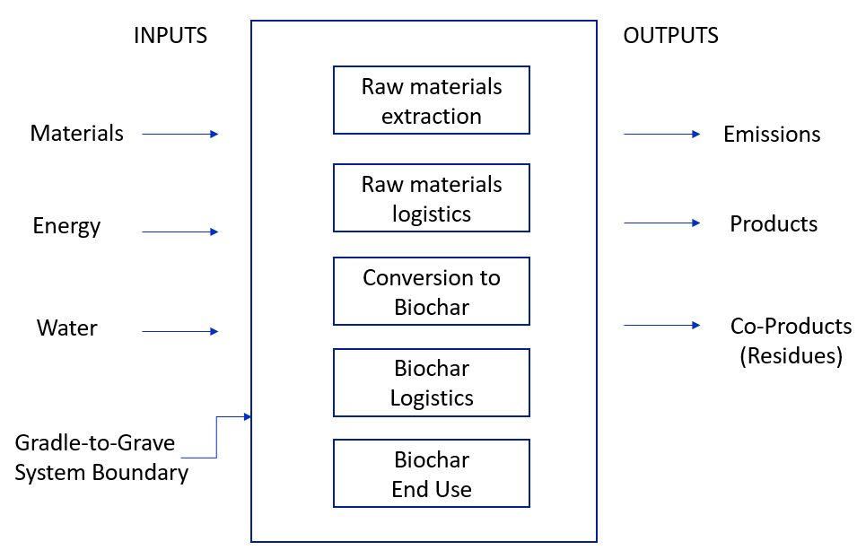

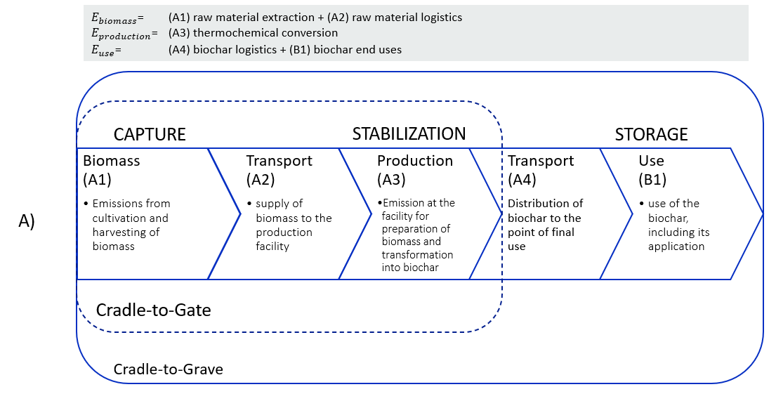

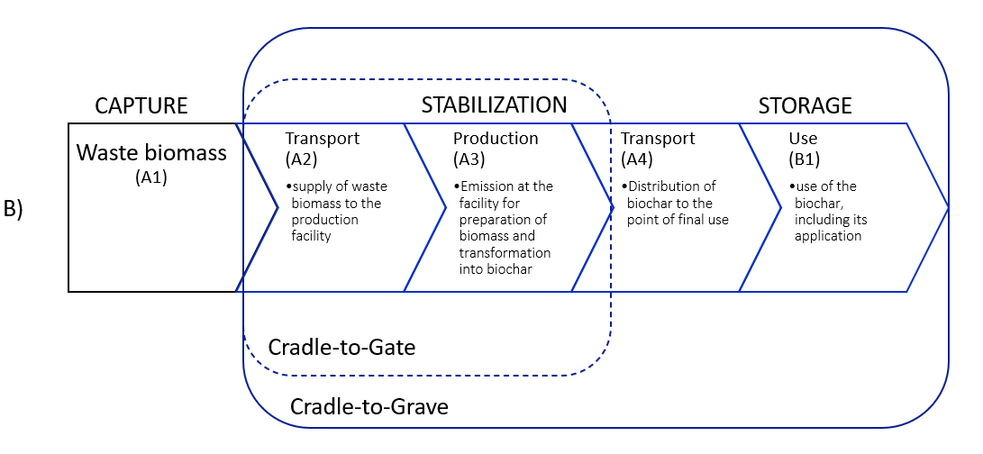

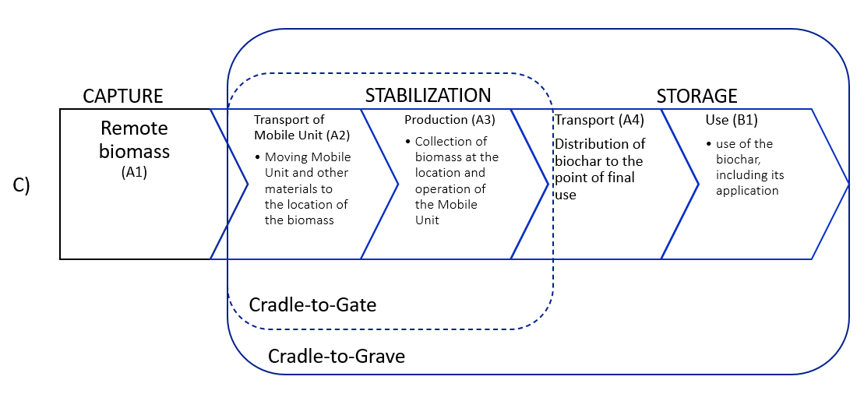
Figure 1. Overall System Boundary for life cycle assessment of a biochar activity (continued). The details about the calculation of greenhouse gas emissions for each stage are described in Chapter 4.

4 Calculation methodology for the quantification of CO₂ Removal

The purpose of this section is to present how to calculate the amount of carbon dioxide removal certificates (CORCs) resulting from the biochar production activity over a given reporting period, i.e. for a given amount of biochar produced. First, the overall equation and its parameters are presented. Then, details about the calculation of each term are summarized.

4.1 Overall equation for net carbon sequestration over 100 years
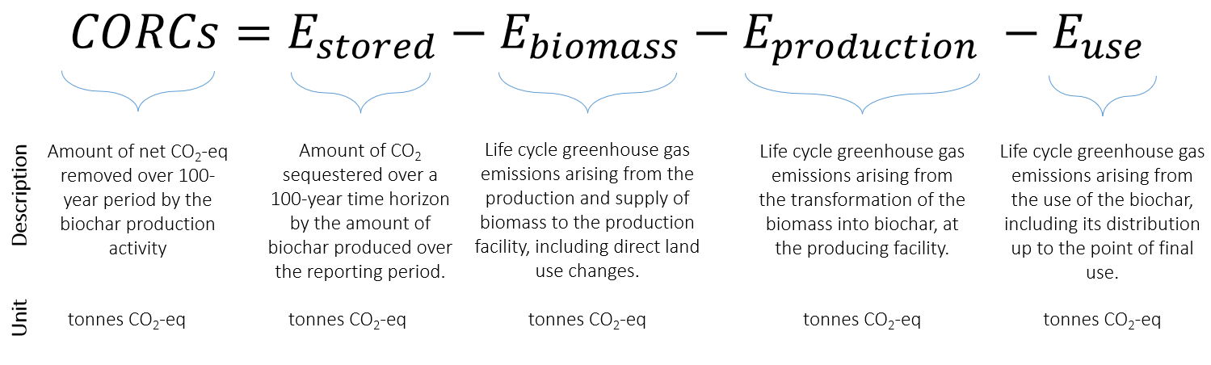

Figure 1. Overall equation to calculate the amount of CORCs supplied by the biochar production activity over a given reporting period. The tonnes unit refers here to metric tonnes (i.e. 1000 kg). All terms are counted as positive.
The overall equation is made of four terms (Figure 3). The first term ($E_{stored}$) describes the amount of carbon dioxide sequestered over a 100-year time horizon by the amount of biochar produced. Its calculation is explained in section 0, and is based on new results published in the peer-reviewed scientific literature. The second term ($E_{biomass}$) describes the life cycle greenhouse gas emissions arising from the production and supply of biomass to the production facility, including direct land use changes. The third term ($E_{production}$) describes the life cycle greenhouse gas emissions arising from the transformation of the biomass into biochar, at the producing facility. Finally, the fourth term ($E_{use}$) describes the life cycle greenhouse gas emissions that occur along the distribution of the biochar up to its point of final use. Guidelines for calculation of${ E}_{biomass}$, $E_{production}$, and $E_{use}$ are given in sections 4.3, 4.4, and 4.5, respectively.

Remark on sign conventions: In the equation above (Figure 3), the amount of CORCs and the four terms are positive numbers. The amount of CORCs supplied is equal to the amount of carbon dioxide sequestered by the biochar minus life-cycle emissions from the pyrolysis process, the biomass provision, and the biochar use.

4.2 Biochar carbon storage ($E_{stored})$

The term $E_{stored}$ is calculated based on the methodology by Woolf and colleagues (2021)¹⁰ that provides an estimate of biochar carbon sequestration at any given time horizon$TH$, for biochar used in soils at any soil temperature${ T}_{S}$. For the purpose of this methodology, the time horizon$TH$ is set to 100 years. If needed, results can be calculated at any other time horizon using the supplementary information provided by Woolf and colleagues (2021)¹⁰. Regarding soil temperature${ T}_{S}$, there are large differences in 100-year biochar carbon sequestration between climates. Therefore, the methodology must be applied for a mean annual soil temperature${ T}_{S}$ representative of the climate where the biochar is distributed and used. The global mean annual cropland temperature is about 14.9°C, but can vary between 5°C and 25°C between world regions.

Biochar used first in non-soil applications may have slower degradation rates. However, to date, no peer-reviewed methodology exists for estimating long-term carbon sink in such products. Therefore, the existing methodology for decomposition in soils is used even for non-soil applications, and it can be seen as a conservative estimate.

The methodology presented by Woolf and colleagues (2021) suggests three ways of calculating biochar carbon sequestration, based on the available information. Here, for the purpose of the Puro Standard methodology, only the first option is used, as is it recommended as the most accurate option.

The term $E_{stored}$ is therefore given by the equation:

$$E_{stored}=Q_{biochar}×C_{org}×F_{p}^{TH, T_{s}}× \frac{44}{12}$$

In this equation, three parameters are involved as well as a conversion factor:
- $Q_{biochar}$ is the amount of biochar produced over the reporting period. It is expressed in dry metric tonnes of biochar. Care must be taken to exclude any moisture, as including water would lead to an overestimation of the carbon actually sequestered.

- $C_{org}$ is the organic carbon content of the biochar produced. It is expressed in dry weight of organic carbon over dry weight of biochar. $C_{org}$ is determined by laboratory analyses of the biochar produced, with a representative sampling methodology. Care must be taken in case of very diverse biomass is used to produce biochar, so that the laboratory analyses are made for each type or batch separately.

- $F_{p}^{TH, T_{s}}$ is the permanence factor of biochar organic carbon over a given time horizon $TH$ in a given soil at temperature $T_{S}$. It is also known as biochar carbon stability, and it is expressed as a percentage (%). At a given $TH$ and $T_{s}$, the permanence factor $F_{p}^{TH, T_{s}}$ is only a function of the molar $H/C_{org}$ ratio of the biochar and follows the linear relationship below:
$$F_{p}^{ TH, T_{s}}=c+m×H/C_{org}$$
The molar $H/C_{org}$ ratio of a biochar sample is derived from the laboratory analysis as given or calculated from laboratory analyses dividing the hydrogen mass content by the organic carbon mass content of the biochar, and multiplying this with the ratio of carbon molar mass over hydrogen molar mass. In other words:
$$H/{C_{org}}\left(molar\right)=\frac{m_{H}(\%)}{m_{C} (\%)}×\frac{M_{C} (g mol^{-1})}{M_{H}(g mol^{-1})}= \frac{m_{H}(\%)}{m_{C} (\%)}×\frac{12}{1.0}$$

The regression coefficients $c$ and $m$ are a function of the time horizon $TH$ and the soil temperature$T_{s}$. Table 1 below provides the values of these two coefficients for a time horizon $TH$ of 100 years, and for a range of soil temperatures${ T}_{s}$. To select the appropriate coefficients $c$ and $m$ to use, the biochar producer should consider the regions where the biochar is likely to be used. If a main region for biochar use cannot be defined, the global mean soil temperature of 14.9°C can be used as a default value.
Remark on $F_{p}^{ TH, T_{s}}$ values above 100%: at lower soil temperatures and with biochars having a low $H/{C_{org}}$, it is possible that the linear regression provides $F_{p}^{ TH, T_{s}}$ above 100%. In that case, the value should be set equal to 100%.

Table 1. Regression coefficients for estimating biochar stability for a time horizon $TH$of 100 years at various soil temperatures $T_{s}$. Values for the closest soil temperature should be used.
Soil temperature $T_{S}$ | $$c$$ | $$m$$
5°C | 1.13 | -0.46
10°C | 1.10 | -0.59
15°C | 1.04 | -0.64
20°C | 1.01 | -0.65
25°C | 0.98 | -0.66
14.9°C | 1.04 | -0.64

- Finally, the factor $\frac{44}{12}$ is the ratio between the molar mass of carbon dioxide and the molar mass of carbon. This factor converts an amount of carbon to its corresponding amount of carbon dioxide.

Calculation examples
Five biochars were produced by different suppliers (A-E). After accounting for the moisture in the biochar, the biochar production amount is 1000 dry metric tonnes. Lab analyses were performed to determine the organic carbon content and the hydrogen content of the biochar, expressed in dry mass. With this information, the $E_{stored}$ term is calculated at three different soil temperature.

At 10°C, the $E_{stored}$ values are:
Biochar | $$Q_{biochar}$$ | $$C_{org}$$ | $$H$$ | $$H/{C_{org}}$$ | $$F_{p}^{TH, T_{s}}$$ | $$E_{stored}$$
# | dry tonnes | % | % | mol/mol | % | tonnes CO₂
A | 1000 | 93.8% | 1.3% | 0.16 | 100% | 3439
B | 1000 | 93.2% | 1.1% | 0.15 | 100% | 3417
C | 1000 | 83.9% | 1.68% | 0.24 | 95.8% | 2948
D | 1000 | 47.9% | 1.1% | 0.27 | 94.1% | 1652
E | 1000 | 87.7% | 1.41% | 0.19 | 98.8% | 3177

At 14.9°C, the $E_{stored}$ values are:
Biochar | $$Q_{biochar}$$ | $$C_{org}$$ | $$H$$ | $$H/{C_{org}}$$ | $$F_{p}^{TH, T_{s}}$$ | $$E_{stored}$$
# | dry tonnes | % | % | mol/mol | % | tonnes CO₂
A | 1000 | 93.8% | 1.3% | 0.16 | 93.8% | 3225
B | 1000 | 93.2% | 1.1% | 0.15 | 94.4% | 3226
C | 1000 | 83.9% | 1.68% | 0.24 | 88.6% | 2727
D | 1000 | 47.9% | 1.1% | 0.27 | 86.7% | 1523
E | 1000 | 87.7% | 1.41% | 0.19 | 91.8% | 2953

At 25°C, the $E_{stored}$ values are:
Biochar | $$Q_{biochar}$$ | $$C_{org}$$ | $$H$$ | $$H/{C_{org}}$$ | $$F_{p}^{TH, T_{s}}$$ | $$E_{stored}$$
# | dry tonnes | % | % | mol/mol | % | tonnes CO₂
A | 1000 | 93.8% | 1.3% | 0.16 | 87.4% | 3007
B | 1000 | 93.2% | 1.1% | 0.15 | 88.1% | 3011
C | 1000 | 83.9% | 1.68% | 0.24 | 82.2% | 2528
D | 1000 | 47.9% | 1.1% | 0.27 | 80.2% | 1408
E | 1000 | 87.7% | 1.41% | 0.19 | 85.5% | 2748

4.3 Biomass production and supply ($E_{biomass})$

The term $E_{biomass}$ should be derived from a life cycle assessment of the biomass production and supply to the biochar production site. Typically, the life cycle assessment of biomass production and supply includes three terms:
- Biomass production: this term shall include greenhouse gas emissions arising from all activities involved in the biomass cultivation and harvesting process, like the use of machinery and fuel, the production of fertilisers, emissions from soils following fertiliser use, machinery manufacturing and disposal.

- Direct land use changes: this term represents emissions arising at the site of cultivation of the biomass that are related to a change in land cover or land management. This can represent the emissions of carbon dioxide and other greenhouse gases from reforestation but also the loss of carbon in aboveground and belowground stocks when harvesting forest residues or agricultural residues. In many cases, direct land use changes are given a null value (0 emission from changes in biogenic carbon stocks), but this must be justified adequately with an explicit reference situation.

- Biomass transport: this term shall include emissions arising from transport of the biomass from the harvest site to the biochar production site, ideally including fuel emissions, but also vehicle and road infrastructure emissions.

Mobile unit transport: when a mobile carbonizer or similar movable unit is used, this term shall include emissions arising from moving the unit to the biomass location.

4.4 Biochar production ($E_{production})$
The term $E_{production}$ should be derived from a life cycle assessment of the biochar production process. This term should include all greenhouse gas emissions from the activities involved in the conversion of biomass to biochar.

List of activities that may be relevant to include in the life cycle assessment:
- Biomass handling on site (transport or conveying of the biomass within the facility)
- Drying, chipping, comminution, and/or sieving of the biomass
- Operation of the pyrolysis reactor and post-pyrolysis equipment (e.g. combustion chamber for pyrolysis gases and oil, flue gas treatment systems) or operation of the gasifier reactor and post-processing equipment
- Biochar quenching and other post-processing operations (e.g. packaging, activation)
- Biochar handling on site (transport or conveying of the biochar within the facility)
- Mobile unit fuel consumption associated with the operation of the mobile carboniser, near-location collection and handling of the biomass, but also the transport of the fuel to the location where the mobile unit is operated.

For each of the activities above, all life cycle stages (manufacturing, use and disposal) should be included. For instance, the operation of the pyrolysis reactor should include manufacturing and installation of the reactor, material and energy inputs for operating the reactor, direct air emissions from the stack of the reactor, and maintenance and disposal of the reactor. Likewise, biomass drying and chipping should for instance include manufacturing and disposal of the drying and chipping equipment, direct energy use from operation of the equipment (e.g. electricity or external heat), and eventually other consumables involved in the operation and maintenance of the equipment.

Remark on handling of co-products from the pyrolysis process:
- Depending on the configuration of the pyrolysis reactor, several other products may be generated, such as heat, electricity, or bio-oil. In most cases, a fraction of the heat generated from the combustion of the pyrolysis gases is used for sustaining the pyrolysis reaction and drying the biomass. This is an energy flow internal to the pyrolysis process and has no effect on the life cycle assessment (i.e. it does not need to be included).
- However, any excess heat, excess electricity or excess bio-oil that is not used within the pyrolysis process leads to a multi-functionality issue in life cycle assessment. In classical life cycle assessment, this can be dealt with in several ways depending on the goal and scope of the LCA, mainly: allocation or substitution.
- Here, for the purpose of the methodology, the following approach should be used:
  - If the pyrolysis co-products represent high-value products or a large share of the initial biomass energy content, then an energy allocation between the biochar and the co-products must be applied. The life cycle assessment must specify how the allocation factors were calculated, in particular which energy unit was used (lower heating value, higher heating value, or another method).
  - If the pyrolysis co-products are not deemed an important product, then all the burdens are allocated to the biochar production (allocation factor of 100%), and any excess co-product is considered as burden free (allocation factor of 0%).

4.5 Biochar use ($E_{use}$)

The term $E_{use}$ should be derived from a life cycle assessment of the expected biochar use, to the extent that it is known by the biochar producer. This term should include at least all greenhouse gas emissions from the transportation and handling of biochar until it is used in a mineral matrix (soil or concrete) from which it cannot be separated.

5. Proofs needed from the CO₂ Removal Supplier

5.1 Principle

5.1.1. The biochar output from a production facility is determined as eligible for issuance of CO₂ removal certificates once the facility has undergone a process of third-party verification by an auditor against the specific methodology for biochar. This verification is done in a Production Facility Audit. The verification ensures that the corresponding CO₂ removal has taken place, and relevant Environmental and Social Safeguards are in place and that the CO₂ removal is considered permanent as defined in the methodology.

5.1.2 For the activity to be eligible for producing biochar for which CO₂ removal certificates can be issued, the following proofs (5.2- 5.4) need to be presented by the CO₂ Removal Supplier (in this case, the producer of biochar).

5.2 Biomass production and supply

5.2.1 Proof of the sustainability of the raw material used. Proof to be presented:

In case of forest biomass raw material:
- Forest Stewardship Council (FSC) Forest Management Certification; or
- Sustainable Forestry Initiative (SFI) Forest Management Certification; or
- Programme for the Endorsement of Forest Certification (PEFC) Sustainable Forest Management Standard; or
- Other reputable sustainable forest certification programs with high scientific standards and market recognition, regardless of whether they are public or private in nature. Puro.Earth reserves the right to make the determination of eligibility of the certification program.
In case of other waste biomass raw material:
- Raw material needs to be sourced sustainably; however, certificates are not needed, as it is waste material.

5.2.2 Life cycle assessment data for the biomass production and supply must be provided and documented. In particular, climate change impact must be presented in a disaggregated way exhibiting the contribution of the different life cycle stages described in section 0.0

5.3 Biochar production

5.3.1. The biochar producer must provide data trail and documentation on the amount of biochar produced. This includes: i) continuous production documentation for the whole period (record keeping), taking into account any significant changes or stops in production, and ii) data and methodology applied to calculate the dry mass of biochar produced

5.3.2. The mobile unit or carbonizer operator must, at a minimum, provide the following data on the amount of biochar produced: i) continuous load cell measurement of the biochar production for the whole period ii) water input measurement. Dry mass of the amount of produced biochar is calculated using the measured weight of biochar from load cells deducted with the weight of the water that was input. Additional measurement equipment for greater accuracy can be proposed by the operator.

5.3.2. Life cycle assessment data for the biochar production process must be provided and documented. In particular, climate change impact must be presented in a disaggregated way exhibiting the contribution of the different life cycle stages described in section 0.

    - The following biochar properties must be determined via laboratory analyses, as they are required for the quantification of the biochar carbon sequestration: total organic carbon content, total hydrogen content, and calculated $H/{C_{org}}$ratio.

5.4 Biochar use

5.4.1. Life cycle assessment data for the biochar use must be provided and documented. In particular, climate change impact must be presented in a disaggregated way exhibiting the contribution of the different life cycle stages described in section 4.

5.4.2. Proof that the end-use of the product does not cause CO₂ returning to the atmosphere (it is not used as fuel or reductant). The proof can be an offtake agreement, documentation of the sale or shipment of the product, indicating the intended use of the product. Care should be taken to exclude amount of biochar that is likely to end up in waste incineration and not in a mineral matrix (soil or construction use) from which it cannot be separated.

5.4.3. Justification on the soil temperature selected for the calculation of the biochar carbon sequestration.

5.5 No double-counting

5.5.1. Double counting is avoided by the use of the Puro Registry, with a system of unique identification of each CORC that guarantees it is only used once. Each CORC in the registry contains information on Production Facility registration and crediting period dates, verification, issuance and retirement transactions as well as the title and ownership over time.

5.5.2 A statement is needed from the CO₂ Removal Supplier that the underlying physical product (biochar) in which the CO₂ is stored will not be sold or marketed as “climate positive” if the CO₂ removal certificate associated with the underlying physical product (biochar) is removed from the underlying product and sold to another stakeholder not associated with the underlying physical product.

5.5.2. Check of the packaging of the product (how the product is branded) is needed, if CO₂ removal certificate associated with the underlying physical product (biochar) is removed from the underlying product.

5.5.3. No marketing and branding claims can be made by the end-user (user of biochar) that the underlying physical product (biochar) is a carbon sink, when the decoupled CO₂ removal certificate has been sold to and accounted by another stakeholder not re-associated with the underlying physical product. The proof can be an offtake agreement, documentation of the sale or shipment of the product, indicating the procedures for claiming the CO₂ removal certificate.

Annex B: Carbonated Building Element Methodology
This methodology quantifies the CO2 Removal achieved by production of Carbonated Building elements.
CO2 Removal results from the chemical binding of CO2 into the building element during the hardening phase.
This methodology is applicable to certificates issued for the Puro.earth Standard.

Eligible activity type

Activity capable of producing as Output carbonated building element that is net CO2 removing. CO2 Removal is achieved through carbonation. Carbonation is a chemical reaction between CO2 and Metal hydroxides or oxides (CaOH, MgOH, CaO, MgO) to form a strongly-bonded, stable carbonate mineral (CACO3, MGCO3).
The Net CO2 Removal is determined by subtracting the CO2 emissions generated directly or indirectly due to the production process from the CO2 absorbed and stored due to the carbonation reaction.
The eligibility of the production facility is determined in the Production Facility Audit.

2. Requirements for the Production Facility Audit

2.1. Eligibility of the Production Facility to be approved into the System

2.1.1. The Production Facility Auditor checks the Production Facility against the Requirements for activities to be eligible under the methodology (section 1), and the Proofs and evidence needed from the CO2 Removal Supplier (section 6). The main requirements include:
- Verifying that the production facility is technologically capable of producing the eligible Output (carbonated building elements) and that the carbon content is as specified (6.3.).
- The raw material used in the carbonated building element production is of eligible type and that EU and national legislation is followed in its sourcing and extraction (see sections 1. and 6.2).
- If the supplier has referred to a voluntary sustainability scheme or certificate as proof of sustainability (the sustainability is verified by a third party), the validity of the certificate is checked by the Auditor (6.2.).

2.1.2. The Production Facility Auditor checks that the Production Facility is capable of metering and quantifying the Output in a reliable manner, for the Quantification of CO2 Removal (section 5). This check also prepares the CO2 Removal Supplier for producing the periodic Output Report.
- The quantity of the carbonated building elements produced is quantified and documented in a reliable manner (sections 5.1. and 5.4.)
- Relevant meters are in place and they are calibrated;
- The energy use of the Production Facility can be quantified and the emissions from the process calculated (section 6.3.);
- The emissions from the extracting and transporting of the raw material are estimated and calculated in a reliable manner (section 6.2.)
- The size of the buffer for uncertainty (section 5.3) is correct for the Production Facility in question
- The auditor goes through the Quantification of CO2 Removal requirements with the CO2 Removal Supplier, so that the Removal Supplier is able to calculate the CO2 Removal independently in its Output Report.

2.1.3. Collection of standing data of the Production Facility
The Production Facility Auditor collects and checks the standing data of the Production Facility and the CO2 Removal Supplier. The data to be collected by the Auditor includes:
- CO2 Removal Supplier registering the Production Facility;
  - A certified trade registry extract or similar official document stating that the organization is validly existing and founded under the laws of the mother country.
- Location of the Production Facility;
- Volume of Output during the full calendar year prior to registration;
- Removal Method(s) for which the plant is eligible to receive CORCs;
- Date on which the Production Facility becomes eligible to receive CORCs;
- Whether the Production Facility has benefited from public support.

3. Point of creation of the CO2 removal certificate

3.1. Point of creation

3.1.1. The point of creation of the CO2 removal certificate is the production of the carbonated building element that has absorbed CO2 at the eligible production facility.

3.1.2. The producer of the carbonated building element is the CO2 Removal Supplier.

3.1.3. The carbonated building element that possesses the CO2 absorbing characteristics is used in construction to replace currently used concrete elements that are manufactured using conventional technologies.

4. Activity boundary for CO2 removal certificate

4.1. Activity boundary

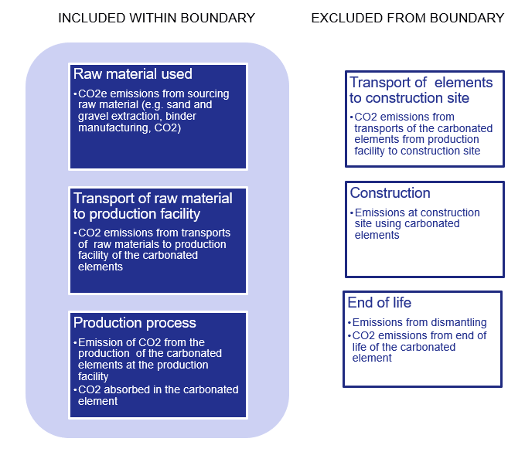
4.1.1. Issues inside the blue box are inside the activity boundary. Emissions from the raw materials, transport of raw materials and production of the carbonated building elements are included in the calculation of CO2 emissions of the carbonated elements. See figure 1 below.

Figure 1. Activity boundary

4.1.2. Included within the boundary
- Raw material used: CO2 emissions from extraction and production of the raw material used for the production of the carbonated elements.
- CO2 emissions from transporting the raw material to the production facility where the carbonated building elements are produced.
- If the raw material is classified as a waste product the emissions are zero at the point of creation of the waste. CO2 emissions for transport from the point of creation of the waste to the production site are in this case included within the boundary.
- Leakage of CO2 from the finished product in normal use conditions does not occur (but is within the boundary).
- The carbonated element will be used for construction purposes only and the storage of CO2 is a priori permanent regardless of the use of the carbonated building elements. Thus, no further proof regarding its specific end-use is required other than that its characteristics make is possible to use for construction (proof is obtained in the Production Facility Audit).
4.1.3. Excluded from the boundary
- Transport of the carbonated building elements from the production facility, where the carbonated building element is produced, to the construction site are not within the boundary.
- End of life emissions from demolition or other transformations at end of life are not considered. At end of life the carbonated element retains the stored CO2 – hence the removal is a priori permanent. The demolition of a house or other constructions made from the carbonate building element does not impact the CO2 storage capability.

5. Quantification of CO2 Removal – calculation methodology

5.1. Production volume

5.1.1. The producer of the carbonated building element (Removal Supplier) provides data and documentation on the production volume (in kg) of the carbonated elements produced in the production process of the eligible production facility.

5.2. CO2 storage volume (CO2 captured in the carbonated building element)

5.2.1. The amount of storage of CO2 in the carbonated element is based on measurements or on other scientifically sound methods verified by a qualified third party auditor.
5.2.2. The information from a reliable LCA or EPD verified by a third party auditor can also be used.

5.3. Buffer for uncertainty assessment

5.3.1 A Buffer is used to correct the Output to account for possible uncertainties in e.g. metering inaccuracies, losses of the CO2 storage after production, or other losses that may occur. A correction in the form of a buffer in percentage (%) is used to reflect the uncertainty and to reduce the volume of CO2 removal Output to be certified i.e. uncertainty-corrected CO2 Removal Output=Output*(100%-Buffer)
5.3.2. During production: Metering inaccuracies in production volumes, in CO2 content in the element due to sampling or testing techniques, or other metering used in quantification needs to be estimated and a corresponding buffer-percentage defined
5.3.3. During use: The amount of decomposing or re-emitting of CO2 in the normal use of the product needs to be estimated. If there is no re-emitting or decomposition, proof needs to be presented that the product does not leak CO2 and the storage is permanent in normal conditions (e.g. theoretical calculations, chemical formulas or test results).
5.3.4. Any other uncertainties or other losses of the CO2 Removal Output that may occur needs to be estimated and corresponding buffer-percentage defined.

5.4. Emissions from the activity of producing the carbonated CO2 absorbing elements and for the supply chain that is included within the boundary

5.4.1. Calculation of CO2e emissions from the supply chain of the raw material used in the production of the element, including transport of the raw material to the production facility.
5.4.2. Calculation of CO2 emissions from the production process of the carbonated building elements, for the monitoring period. Emissions from e.g. energy use or other CO2 losses in the production process are calculated from actual data.
5.4.3. The calculations need to be done according to standards ISO 14067 Greenhouse gases- Carbon footprint of products - Requirements and guidelines for quantification, EN 15804 or similar.
5.4.5. The information from a reliable LCA or EPD verified by a third party auditor can also be used.
5.4.6. Leaking CO2 during production process is included in the emissions calculation.

5.5. Use of existing EPD or LCA as proof

5.5.1. Existing Life Cycle Analysis (LCA) results or Environmental Product Declaration (EPD) that has the same scope and boundaries as described above (A1-A3) and which has been verified by a third party can be used as sufficient proof for (4.2 – 4.4).

5.6. Calculation parameters
Q_{celements} = Production volume of carbonated elements produced (in kg)
C_{celements =} CO2 storage volume per element (in kg CO2 / kg elements)
B_{celements} = Buffer for possible CO2 re-emitted during Product life-time (in percentage)
E_{celement} = Net emissions from carbonated element production at the production facility (kg)
L_{celements} = Leakage of CO2 in production process (kg)
ET_{rawmaterial} = Emissions from transport of raw materials to the carbonated element production facility (kg)
E_{rawmaterial} = Emissions from extraction or production of raw material before transport to the element production facility (kg)

5.7. Calculation formula of CO2 content

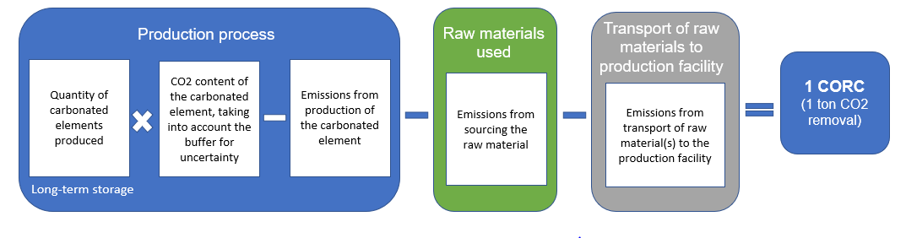

Q_{celement} $×$ (C_{celement} *(100%-B_{celement})) - (E_{celement} $+$ L_{celement}) – (ET_{rawmaterial} $+$ E_{rawmaterial} ) = CO₂ Removal ( kg)

Proofs and evidence needed from the CO2 Removal Supplier

Principle

6.1.1. Output from a production facility is determined as eligible for issue of CO2 removal certificates once the facility has undergone a process of third-party verification by an auditor against the specific methodology for the carbonated building element. This verification is done in a Production Facility Audit. The verification ensures that the corresponding CO2 removal has taken place and that the CO2 removal is considered permanent as defined in the methodology.
6.1.2. For the activity to be eligible for producing carbonated building elements for which a CO2 removal certificate can be issued, the following proofs (6.2- 6.4) need to be presented by the CO2 Removal Supplier (in this case, the producer of CO2 positive carbonated building elements).

Raw materials used

6.2.1. Proof of raw material use: Information is needed on the used materials and their composition, CO2 emissions from extraction and manufacturing. The raw materials (e.g. sand, gravel, binder, CO2, water) should be sustainably sourced and sourced in accordance to local and EU legislation. If there is a national or other applicable scheme for sustainable sourcing, it is recommended that it is used. (One example is the Dutch, Environmental Performance based on the Determination Method, which enables comparing the sustainability of raw-materials, more information www.nibe.info.)
6.2.2. The proofs can be in the form of third party verified LCA or EPD.

Production process of the CO2 positive carbonated product and quality of the product

6.3.1. Proof of CO2 positive production: Proof is needed that the production process and technology used for the manufacturing of the carbonated building element results in a net CO2-positive product. Description of the technology used is needed (capability of the facility of producing carbonated elements).
6.3.2. Lab test results or other scientifically reliable analysis or evaluation by a trusted third party is needed on the amount of CO2 that is absorbed in an element as well as for the CO2 emissions created in the production process (e.g. energy use or CO2 emitted or lost in the production process).
6.3.3. Proof is needed on of the amount of leakage or no leakage of CO2 from the carbonated element after production. The proof can be in the form of a chemical formula or other science-based method that can be verified by a qualified third party.
6.3.4. Proof of quality of the carbonated element must be presented utilizing existing, credible lab test results of product quality (composition of the product) and assessment by a third party that the product can be used for construction purposes.
6.3.5. The data regarding the producer of the carbonated building element needs to come from primary sources and needs to be valid (representative) for the period for which the declaration is issued.
6.3.6. Standards to be used are ISO 14067 Greenhouse gases- Carbon footprint of products - Requirements and guidelines for quantification and EN 15804 or similar.

Proof of the end use of CO2 removing product

6.4.1. Proof of the end use of the CO2 removing product: No separate proof of end use or use in construction is necessary for the carbonated building element. The product is used in construction and will in normal use not be heated to temperatures where CO2 leaks (temperature where there could be a CO2 leak is at temperatures above 800 C). The CO2 stored in the product will not be re-emitted in case the house or construction where the product is used is demolished. The crushed elements can be reused (e.g. used for road construction or used again in new carbonated products) without the captured CO2 leaking.

Proof of no double counting

6.5.1. A statement is needed from the Removal Supplier that the underlying physical product (carbonated building element) in which the CO2 is stored will not be sold or marketed as “carbon positive” if the CO2 removal certificate associated with the underlying physical product (carbonated building element) is removed from the underlying product and sold to another stakeholder not associated with the underlying physical product.
6.5.2. No marketing and branding claims can be made by the end-user (e.g. construction company) that a building constructed with the underlying physical product (carbonated building element) is a carbon sink if the decoupled CO2 certificate has been sold to and retired by another stakeholder not associated with the underlying physical product.

Annex C: Wooden Building Element Methodology
This methodology quantifies the CO2 Removal achieved by production of wooden building elements.
CO2 Removal results from the wooden building elements storing the carbon captured by trees. The CO2 removal is considered long-term, when used in construction of buildings.
This methodology is applicable to certificates issued for the Puro.earth Standard.

Eligible activity types

1.1 Requirements for activities to be eligible under the methodology
1.1.1. Production of engineered wooden building elements (mass timber elements, glued laminated timber, cross-laminated timber, laminated veneer lumber or cellulose fiber insulation CFI), sourced from sustainably managed forests and plantations in Europe, and used for the construction of buildings.
1.1.2. Elements need to be installed-to-measure, pre-cut and ready for construction when shipped from the production facility, so that there is no material loss at the construction site which would decrease the CO2 Removal captured by and embedded in the product.
1.1.3. The eligibility of the production facility is determiner in the Production Facility Audit

1.2 Requirements for the Production Facility Audit
1.2.1. The Production Facility Auditor checks the Production Facility against the Eligible activity types (section 1), and the Proofs and evidence needed from the CO2 Removal Supplier (section 5). The main requirements include:
- The raw materials used in the production of the elements are sustainably sourced (see section 1.1 and 5.2.1.)
- The Production Facility has a valid Environmental Product Declaration or similar certificate, Auditor checks date of certificate issuance (see section 5.3.1.);
- The building elements are of eligible type and the elements are pre-cut and ready for construction when shipped from the production facility, so that there is no material loss at the construction site which would decrease the CO2 Removal impact after shipping.
1.2.2. The Production Facility Auditor checks that the Production Facility is capable of metering and quantifying the Output in a reliable manner, for the Quantification of CO2 Removal (section 4). This check also prepares the CO2 Removal Supplier for producing the periodic Output Report.

- The quantity of the wooden building elements produced and shipped is quantified and documented in a reliable manner (sections 4.1.1., 5.3.2. and 5.4.)
- Relevant meters are in place and they are calibrated;
- The energy use of the Production Facility can be quantified and the emissions from the process calculated (section 4.4.2.);
- The emissions from the harvesting and transporting of the raw material are estimated and calculated in a reliable manner (section 4.4.4.)
- The size of the buffer for uncertainty (section 4.3.3.) is correct for the Production Facility in question
- The auditor goes through the Quantification of CO2 Removal requirements with the CO2 Removal Supplier, so that the Supplier is able to calculate the CO2 Removal independently in its Output Report.

1.2.3. Collection of standing data of the Production Facility
The Production Facility Auditor collects and checks the standing data of the Production Facility and the CO2 Removal Supplier. The data to be collected by the Auditor includes:

- CO2 Removal Supplier registering the Production Facility;
o A certified trade registry extract or similar official document stating that the organization is validly existing and founded under the laws of the mother country.
- Location of the Production Facility;
- Volume of Output during the full calendar year prior to registration;
- Removal Method(s) for which the plant is eligible to receive CORCs;
- Date on which the Production Facility becomes eligible to receive CORCs;
- Whether the Production Facility has benefited from public support.

Point of creation of the CO2 Removal Certificate (CORC)

Point of creation
    - The point of creation of the CO₂ Removal Certificate is the production process of engineered wooden building elements, when the elements are produced and shipped. The end use of the product in construction needs to be proven.

    - The producer of the engineered wooden building elements is the CO2 Removal Supplier.

Activity boundary for CO2 Removal Certificate

Activity boundary

The blue box in the figure 1 below illustrates the activities included in the activity boundary. Emissions from the raw materials, transport of raw materials and production of the wooden building elements are included in the quantification and calculation of CO2 Storage of the wooden building elements.

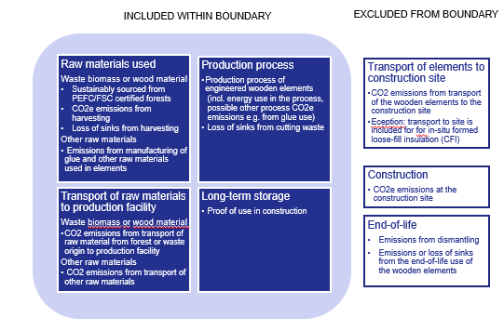
Figure 1: Activity boundary

    - Included within the boundary:
- Waste biomass or wooden raw material needs to be sourced from forest or plantations in the European Union that are certified with Programme for the Endorsement of Forest Certification (PEFC) Sustainable Forest Management Standard or Forest Stewardship Council (FSC) Forest Management Certification.
- Waste biomass or wooden raw materials sourcing: Quantify emissions and possible loss of sinks from sourcing or harvesting of the raw material, as included in the Environmental Product Declaration (EPD) requirements for construction products and described in the EPD of the engineered wooden building element.
- Other raw materials like glues, adhesives, resins, finishing, fire retardants etc.: Quantify the emissions caused by manufacturing the amount of other raw material used in the wooden building element.
- Emissions from the transport of raw materials to the production facility, as included in the EPD of the engineered wooden building element.
- Quantify emissions of the production process of the engineered wooden building elements including energy use in the process and potential other emissions from the production process, such finishing or blowing in-situ.
- Quantify CO2 storage or carbon content (kg CO2eq.) in the finished element as defined in the Environmental Product Declaration, laboratory tests or other similar verified documents.
- Quantify Duration of the CO2 storage, related to the construction use in specific type of building.

    - Outside the activity boundary:
- Emissions from transport of the wooden building elements to the construction site, as they should be calculated in the carbon footprint of the constructing activity
- Emissions from the construction process, as they should be calculated in the carbon footprint of the constructing activity. Exception: in case of in-situ formed loose-fill CFI the emissions of transport of the CFI insulation material and the installation equipment to construction site is included.

- Use of the wooden material after the dismantling of the building. Depending on the recycling method the CO2 storage of the wooden building element may remain or be decomposed. The CO2 removal impact after life-time of the building in therefore not included in the CO2 Removal Certificate.

Quantification of CO2 Removal – calculation methodology

This calculation can be done with using corresponding figures from an existing Environmental Product Declaration (EPD) of the engineered wooden building elements, using Sections A1-A3 of the EPD. Alternatively, other figures can be used, e.g. from an LCA or carbon footprint calculation, if proof of their quality can be presented.

Production volume

    - The producer of the wooden building element (CO2 Removal Supplier) provides data and documentation on the production volume (in kg) of the elements produced in the production process of the eligible production facility.

CO2 storage volume (CO2 captured and embedded in the product)

  - Calculation of the CO2 storage volume (biogenic carbon content) can be based on data from the Environmental Product Declaration (EPD) or similar certification/declaration of the product. In the EPD the biogenic carbon content of wood is calculated by EN 16449 standard, which is based on the ISO 14067 standard.

Buffer for uncertainty assessment

4.3.1. A Buffer is used to correct the Output to account for possible uncertainties in e.g. metering inaccuracies, losses of the CO2 storage after production, or other losses that may occur. A correction in the form of a buffer in percentage (%) is used to reflect the uncertainty and to reduce the volume of CO2 removal Output to be certified i.e. uncertainty-corrected CO2 Removal Output=Output*(100%-Buffer)
4.3.2 During production: Metering inaccuracies in production volumes, in CO2 content in the element due to sampling or testing techniques, or other metering used in quantification needs to be estimated and a corresponding buffer-percentage defined.
4.3.3. During use: Possible decomposing or re-emitting during the life-time of the product: In case of wooden building elements there is a small risk that the CO2 is re-emitted to the atmosphere before the end of life of the building (see section 4.8.2.). Such unlikely incidents include fire in the building, flooding causing building elements decomposing, and other unlikely incidents.
4.3.4. In case of wooden building elements, the buffer is set at 10%. The buffer can later be amended by the Issuing Body.

Emissions from the activity of producing wooden building elements and for the supply chain that is included within the boundary

4.4.1. Emissions from sourcing or harvesting the raw material
Wood material:
- Estimate of CO₂ emissions from sourcing or harvesting the raw material (as per EPD or similar)
- Estimate of CO₂ emissions from transport of the wood material from the forest to the production facility (as per EPD of other similar).
Other raw material (e.g. adhesives, finishing, fire retardant etc.):
- Estimate of CO2 emissions from the manufacturing of the raw material
- Estimate of CO2 emissions from the transport of the raw material to the production facility

    - Emissions from the activity of production of the product

- Calculation of emissions from the production process for the reported Output period
  - Energy use in the production process, calculation from actual data
  - Other possible Green House Gas emissions from the production process (in ton CO2eq.)

Use of existing EPD or LCA as proof

    - Existing Life Cycle Analysis (LCA) or Environmental Product Declaration (EPD) that has the same scope and boundaries as described above (A1-A3) and which has been verified by a third party can be used as sufficient proof for (4.2 – 4.4).

Calculation parameters

Q_{element} = Quantity of wooden building elements produced and shipped to construction company (in kg or m3)
C_{element =} Carbon content of the wooden building elements (in kg CO2 / kg or m3 of product)
B_{element} = Buffer for possible CO2 re-emitted during Product life-time (in percentage)
E_{element}= Emissions from production of wooden building elements
E_{rawmaterial} = Emissions from sourcing or harvesting the raw material from the forest, including possible loss of sinks from harvesting
ET_{rawmaterial} = Emissions from transport of raw material to the production facility

Calculation formula of CO2 removal

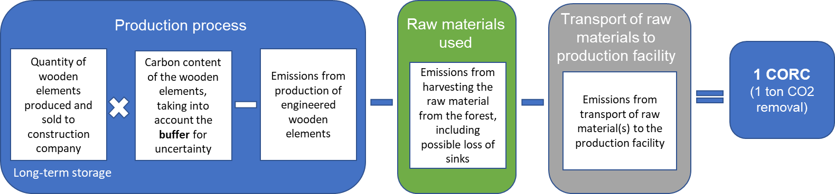

4.7.1. Mathematical formula
Q_{element} $×$ (C_{element} $(100\%-Belement))$ $–$ (E_{element} + E_{rawmaterial} +ET_{rawmaterial}) = CO₂ Removal (in kg)

Note: 1 certificate = removal of 1000 kg CO₂

Long-term CO2 storage

    - The element withholds CO2 captured in the waste biomass or wooden biomass in the forest. The stored amount of CO2 is calculated with the formula above deducting the production process emissions and other emissions from the stored CO2 content in the element.

    - The wooden building element functions as a long-term CO2 storage, when used in a building with long lifetime. Buildings are designed for a lifetime for over 50 years, as required in the European Standard EN 1990 (2002): Eurocode - Basis of structural design. According to the Eurocode standard, the minimum designed lifetimes for all buildings in the EU are the following:

Design working life category | Working life in years
- Building structures and other common structures | Minimum 50 years
- Monumental building structures, bridges and other civil engineering structures | Minimum 100 years

Because buildings in the EU designed to last over 50 years, the CO2 storage in a wooden building is considered long-term.

Proofs and evidence needed from the CO2 Removal Supplier

Principle

    - Output from a production facility is determined as eligible for issue of CO2 Removal Certificates once the facility has undergone a process of third-party verification by an auditor against the specific methodology for the wooden building element. This verification is done in a Production Facility Audit.

    - For the activity to be eligible for producing wooden building elements for which a CO2 removal certificate can be issued, the following proofs (5.2- 5.4) need to be presented by the CO2 Removal Supplier, in this case, the producer of wooden building elements.

Raw material use

    - Proof of the sustainability of the raw material used. Proof to be presented:

- Programme for the Endorsement of Forest Certification (PEFC) Sustainable Forest Management Standard: National standard under the PEFC, such as PEFC Finland Standard (PEFC FI 1002:2014); or
- Forest Stewardship Council (FSC) Forest Management Certification, e.g. FSC Standard for Finland (FSC-STD-FIN-(Ver1-1)-2006);
- or similar

Production process of the engineered wooden building elements and the quality of the product

Product quality
Proof of CO2 removing production – proof that the production technology of the product is net CO2-removing
Proof to be presented:
- Ecological Balance Sheet and/or
- Environmental Product Declaration (EPD) for the wooden building element or the product
- In the case of the EPD, standards EN 15804 and EN 16485 serve as the core product category rules for the assessment. Biogenic carbon content of wood is calculated by EN 16449 standard.
or
- LCA results of the production process, if possible, including information on the carbon sink qualities of the timber; and/or
- Lab results on the quality of the timber, e.g. carbon content of the product.

Proof of production volume
The production volume needs to be proven, as it is the basis of the amount of Certificates to be issued to the Production Facility.
Producer provides Output Report, containing data and documentation on the amount of engineered wooden building elements produced (in kg or m3)
Proof to be presented:
- Continuous production documentation for the whole period (book-keeping), taking into account any significant changes or stops in production

Proof of the end use of CO2 removing product

    - Proof of long-term CO2 storage: proof that the end-use of the product does not cause CO2 returning to the atmosphere
Proof to be presented:
- Shipping documentation of the delivery of the product to a building site, indicating that it is going to be used in construction of buildings.

Proof of no double counting

    - Proof of no double counting on product level: Proof that the final end-use product (e.g. building) will not be sold as “carbon positive/sink” if the certificate is removed from the activity and sold to another organization.
- A statement is needed from the Removal Supplier that the underlying physical product in which the CO2 is stored will not be sold or marketed as “carbon positive/sink” if the certificate associated with the underlying physical product is removed from the underlying product and sold to another stakeholder not associated with the underlying product.
- No marketing and branding claims can be made by the end-user (construction company) that a building constructed with the underlying physical product is a carbon sink if the decoupled CO₂ certificate has been sold to and retired by another stakeholder.

Annex D: List of Issuing Body’s Agents

List of Output Auditors:
DNV GL Business Assurance
EnergyLink Services Pty Ltd
Bio.Inspecta AG
350 Solutions

List of Production Facility Auditors:
DNV GL Business Assurance
EnergyLink Services Pty Ltd
Bio.Inspecta AG
350 Solutions

Annex E: Report and Document Templates
Retirement Request
Question | Answer
Volume of CORCs to be retired
Identifier of CORCs to be retired
Beneficiary name and business identity
Beneficiary country
Use purpose (please specify, where applicable, if the CORC is used for a specific product, general CSR, etc…)
Use time period (e.g. calendar year)
(please specify the time period of operation for the benefit of which the CORC Retirement is used).
Has the Production Facility benefitted from public support? (yes/no)

Output Report
Output Audit Report
Production Facility Audit Report
Production Facility Audit Statement
Production Facility Registration Form
Question | Answer
Name of the CO2 Removal Supplier registering the Production Facility
Name of the Production Facility
Production Facility street address
Production Facility geographical coordinates
Estimated volume of CO2 Removal during the previous calendar year
Removal Method(s) for which registration is sought, being either:
- Biochar
- Carbonated building element
- Wooden building element
Has the Production Facility benefitted from public support? (yes/no)

Annex F: Intentionally left blank

Annex G: Geologically Stored Carbon Methodology

Geologically Stored Carbon

This methodology sets the requirements for eligibility and quantification of the Net CO2 Removal impact achieved by activity carbon sequestration and geo-storage, where CO2 is captured from the atmosphere and stored permanently into deep geological formations by a CO2 Removal Supplier.
Net CO2 removal impact is calculated as net carbon balance of emissions and storages. The gross carbon increase in the geo-storage must be larger than the GHG emissions caused over life-time of the activity.
Capturing CO2 from the atmosphere means either 1) direct air capture, where CO2 is captured from the atmosphere through chemical sorption or by membrane separation or 2) biogenic CO2 capture, where plants have originally captured CO2 from the atmosphere through photosynthesis.
Stored permanently means that CO2 or carbon-containing substance is stored in geological storages in deep, confined rock formations from where the CO2 cannot escape back to atmosphere.
CO2 Removal Supplier is the party contractually responsible for the complete activity with the intent of creating permanent carbon storages by capturing carbon from a biogenic source or directly from the atmosphere and storing into geological storages.
This methodology is applicable to CO2 removal certificates (CORCs) issued by Puro.earth.

Eligibility Requirements

Eligible activity type
Eligible is activity capable of increasing geological carbon stock by storing CO2 or other Green House gases captured directly from atmosphere or from biogenic sources. The CO2 Removal is achieved by storing CO2 into a geological storage. Activities increase the geological carbon stock permanently.
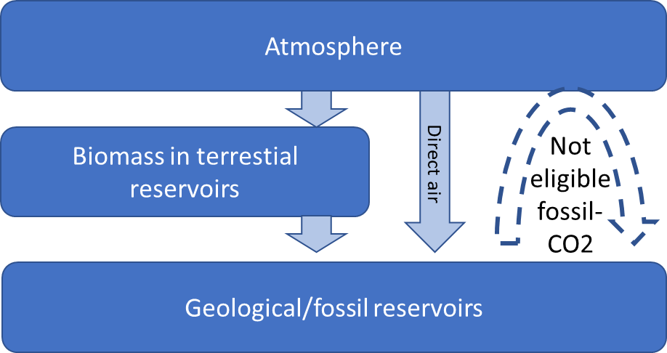

Figure 1. Carbon stocks and eligible and non-eligible CO2 removal activities

Eligible Geological Storage types:
- Direct injection of CO2 into deep geological formations (EPA CLASS VI or EU CCS directive)
- Injection of carbon containing substance into reservoir (EPA CLASS I, II)
- Oil and gas reservoirs as part of EOR+ (EPA CLASS II)
‘EOR+’ refers to Enhanced Oil Recovery by injecting CO2 into oil and gas reservoirs so that more CO2 remains underground than what is contained in the oil extracted by EOR in that reservoir.
Eligible Carbon capture types:
- Direct air capture (DAC)
- Biogenic CO2 from combustion of biomass, bioliquids or biogas (BECCS, bio-CCS)
- Biogenic CO2 fraction from incineration of biomass mixed with other substances (Waste + CCS)
- Biogenic CO2 from biogas upgrading process (Biogas + CCS)
- Biogenic CO2 Carbon capture from oxidization of biogenic materials in industrial processes
- Biogenic carbon-containing substance (carbonaceous liquids, bio-oil, carbon-containing slurry, ethanol, phenol)

Requirements for activities to be eligible
1.2.1 The source of CO2 is biogenic or directly from the atmosphere, i.e. CO2 is captured from atmosphere either through photosynthesis or chemical sorption or by membrane separation.
    - The carbon is stored into geological storages permanently. Eligible geological storages are controlled by EU or US laws and authorities or following similar requirements as set out by those legislations.

    - In case the CO2 source is biogenic, the biomass used is to be sustainable.
    - In case the captured CO2 contains mixed sources (i.e. exhaust or flue gases with both fossil and biogenic sources of CO2), only the biogenic fraction of the CO2 captured is eligible.
    - Non-eligible activities: If the source of the CO2 is purely fossil, the activity is not qualified as Carbon Removal. Fossil point sources of CO2 capture and storage activities are non-eligible because they do not present a net increase of carbon stock in in the geological/fossil storage.
    - The activities should do no net harm to environment, e.g. cause deforestation, loss of biodiversity or to society through loss of arable land and decreased food security, chemical emissions or health risks.
    - The eligibility of the complete activity for the CO2 Removal is determined in the Audit.

1.3 Requirements for the eligibility CO2 Removal Supplier
1.3.1 The Auditor verifies that the CO2 Removal Supplier is capable of metering and quantifying the Net CO2 removal impact, i.e. capable of providing all the calculation parameters in a reliable and consistent manner, for the Quantification of net CO2 Removal as defined in section 4 and Verification evidence as defined in section 5.
1.3.2 The Auditor verifies the CO2 Removal Supplier can prove with contracts or authorization its sole ownership of the carbon removal attribute of the permanently stored carbon.
1.3.2.1 A certified trade registry extract or similar official document stating that CO2 removal Supplier is validly existing and in compliance with the laws of the host country.
1.3.2.2 Contracts with the Capture Operator:
- A certified trade registry extract or similar official document stating that the Capture Plant and its operator are validly existing and in compliance with the laws of the host country.
- Contracts stating that the CO2 Removal Supplier is in contractual agreement with Capture Operator, with the intent of creating permanent carbon storage.
- Proof of sole ownership to CO2 captured or the carbon-containing substance and attestation of no claim to the carbon removal attribute by the Capture Operator⁴
- Contract to allow auditing the Capture Operator’s equipment and documents for Carbon Removal Certificate Issuance purposes
      - Contracts with the Storage Site and Operator,
  - Proof that the Storage Operator is authorized Geological Carbon Storage Provider under national laws and a certified trade registry extract or similar official document stating that the Storage Site is validly existing and in compliance with the laws of the host country.
- the Storage Operator has legal permit and license to store in the reservoir the amount contracted by the project over its entire lifetime
  - Contracts stating that the CO2 Removal Supplier is in contractual agreement with Storage Operator, and the carbon captured is to be received by Storage Operator, injected and stored into permanent storages.
  - Attestation of no claim to the carbon removal attribute by the Storage Operator
  - Contracts to allow auditing the Storage Operator’s equipment and documents for Carbon Removal Certificate Issuance purposes.
      - Contracts with the Logistics Operator (if not the same as Storage Operator),
- A certified trade registry extract or similar official document stating that the Logistics Operator is validly existing and in compliance with the laws of the host country.
- Contracts stating that the CO2 Removal Supplier is in contractual agreement with Logistics Operator, with the intent of creating permanent carbon storage
- Attestation of no claim to the carbon removal attribute by the Logistics Operator
- Contracts to allow auditing the Logistics Operator’s equipment and documents for Carbon Removal Certificate Issuance purposes

- Point of creation of the CO2 Removal Certificate (CORC)
2.1 The point of creation of the CO2 removal certificate (CORC) is the moment when CO2 or carbon-containing substance has been injected into the geological storage and the data records can be verified.
2.2 The CO2 Removal Supplier can be the operator of the carbon capture system / the owner of the carbon capture system / the owner of the captured CO2. The CO2 Removal Supplier does not need to be the same as the operator of the process creating the CO2 to be captured (e.g. the biogas or bioenergy producer or waste treatment facility operator).
  - The CO2 Removal Supplier must prove with contracts or authorization its sole ownership of the carbon removal attribute of the permanently stored carbon.

- Activity boundary for Net-negativity
Net CO2 removal impact is calculated as net carbon balance of GHG emissions and carbon sequestration over life-time of the activity (Life-cycle assessment, LCA). The activity boundaries (system boundaries) determine the processes and their CO2 emissions/storages that are to be included in the Net CO2 removal quantification.
3.1 The activity boundary includes all activities existing solely for the purpose of CO2 Removal. These include the carbon capture, transportation and storing into the geological storages. See figure 2 below.
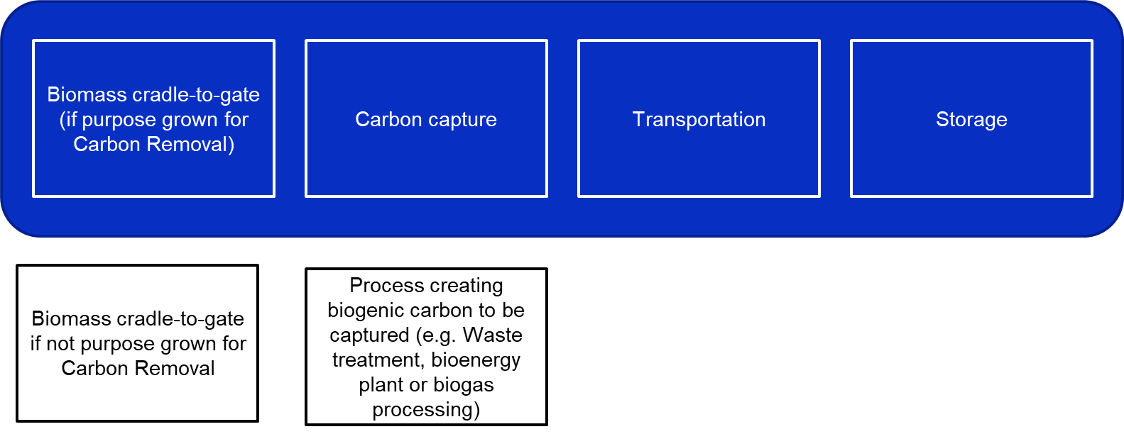
Figure 2: Activity boundary for inclusion in net CO2 Removal impact calculation. (Dark blue activity boxses describe emission included in quantification, White activity boxes describe emissions not included)
  - Emissions included within the boundary: All activities related to capturing (e.g. capture, liquefaction), transporting (e.g. through pipelines or by shipping) and storing (e.g. intermediate storages, injection) of the CO2 and CO2 emissions resulting from these activities.
  - Emissions included within the boundary: Purpose-grown biomass (e.g. emissions from cultivation, harvesting and transportation of the biomass cradle-to-gate) if the biomass is solely grown for CO2 removal purposes. Note: For all activities with biogenic CO2 capture, the biomass must be sustainable, even if the biomass is not purpose-grown but residues or side streams are used.
  - Emissions included within the boundary: Purpose-built equipment and facilities (e.g. emissions from materials and construction) shall be included if they are solely built for CO2 removal purposes. These emissions are included in the carbon balance since they are estimated to be significant (they are more than 1 % of the total emissions). If CO2 Removal Supplier can show that these emissions are less than 1% they can be omitted.
  - Emissions outside the activity boundary: Other activities that do not exist solely for the purpose of CO2 removal even if they are physically connected to carbon capture. These can be e.g. bioenergy production, biogas production or waste treatment. This means that such activities are not considered as integrated but as two separate suppliers: supplier of bioenergy/biogas/waste treatment and supplier of carbon capture (Capture Operator).

Quantification of CO₂ Removal – calculation methodology

Net CO2 Removal calculation
Net CO2 Removal volume (in kgCO2e) for the Project within the activity boundary is to be calculated according to the equation
C_{CAPTURED} - (minus) E_{PROJECT} - (minus) C_{LOSS} = (equals) Net-Carbon-Dioxide-Removal (kg).

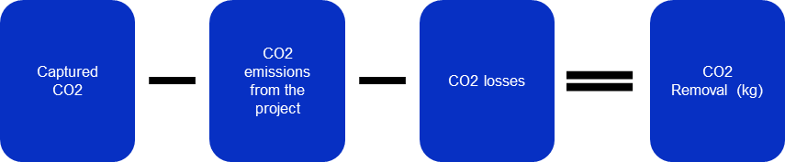
Figure 3. Equation for Calculation of Net CO2 Removal (in kg CO2eq.).

Captured CO2 (in kgCO2e)
    - The CO₂ Removal Supplier provides data and documentation on the planned and/or implemented activities for carbon capture.
    - The CO2 Removal Supplier provides proof of eligible quality of the captured CO2. In the case of direct air capture, the Supplier shall prove that the origin of their CO₂ is atmospheric by providing operational data records that are able to rule out other origins of the CO₂. In the case of biogenic CO2 capture, the Supplier shall utilize carbon isotope (C14) results based on ISO 13833 or ASTM D6866 methods demonstrating biogenic fraction of the captured CO2.
    - In case of carbon-containing substance the quantity of captured CO2e is determined by the carbon content (%) of the substance.
    - In case of EOR+, the quantity of the oil extracted from the same reservoir is deducted (in kgCO2e) from the quantity of CO2 injected (in kgCO2)
    - The CO2 Removal Supplier provides data and documentation on the capture volume (in kgCO2e) of the eligible type of CO2 in the capture site.

CO2 Emissions from the project and CO2 losses
    - Emissions from the Project is the sum of GHG emissions from the activity (geo-stored carbon) included within the activity boundary. Those are: direct emissions (scope 1 and 2) from capture, transport and injection as well as emissions from chemicals, membranes and purpose-built equipment including the construction and materials for the equipment.
    - CO2 losses are regarded as any difference between CO2 captured (total in kgCO2e) and CO2 injected to storage (total in kgCO2e) (see section 4.4 calculation parameters).
    - Energy consumption is substantial in carbon capture activities. All emissions from energy use are within the activity boundary and are accounted for when quantifying the net CO2 Removal. Energy used for geo-stored carbon activities is not required to be 100 % carbon free.

Calculation parameters data provided for verification

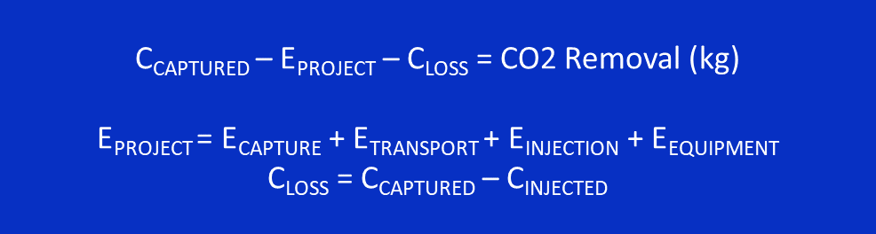

C_{CAPTURED} = CO2 measured at the capture site (in kg CO2e).Eligible fraction is calculated (see 4.2.2-4.2.4)

E_{PROJECT} = Sum of all emissions of all activities within the activity boundary of the CO2 Removal project
E_{CAPTURE} = Emissions from capture phase, emissions from energy use in capture, compression, and liquefaction (in kgCO2e). Emissions from purpose-grown biomass sourcing and conversion to bio-oil cradle-to-gate (see 3.3). (in kgCO2e) Emissions related to capture membranes or chemicals manufacturing and maintenance/regeneration.
E_{TRANSPORT} = Emissions from transportation of captured CO2 from capture site to injection site (in kgCO2e)
E_{INJECTION} = Emissions from injection phase, i.e. emissions from energy use in injection and possible related activities such as intermediate storage (in kgCO2e)
E_{EQUIPMENT} = Emissions from construction of CCS equipment and emissions of materials used for construction of CCS equipment (in kgCO2e). If data of actual emissions is not available, equipment emissions are estimated utilizing the investment (CAPEX) for the equipment with a spend-based emission factor. Emissions from construction are to be amortized fully before issuing first CORCs.
C_{INJECTED} = The amount of CO2/carbon injected into geological storage (in kgCO2e)
C_{INJECTED} For single-user storage site or clearly separate injection wells to the same reservoir, the amount of CO2/carbon injected (in kgCO2e) is measured at the point of injection. Eligible fraction is calculated (see 4.2.2-4.2.49
C_{INJECTED} For multi-user transport and/or storage sites where the injected amount cannot be measured unambiguously per user the amount of injected CO2 (in kgCO2e) if the injected CO2 is a mix from multiple CO2 providers. Thus verifying end-to-end amount of CO2 needs reporting of data regarding the efficiency of logistics and injection: C_{LOSS} = C_{CAPTURED} – (C_{TRANSPORT} x CEfficiency_{LOGISTICS} x CEfficiency_{INJECTION} ), where
  - C_{TRANSPORT} = Amount of total CO2 fed into logistics operator’s system (e.g. to pipeline or to CO2 carrier vessel)
  - CEfficiency_{LOGISTICS} = Efficiency of CO2 logistics (in %), i.e. [the amount of CO2 handed over to storage provider] / [the amount of CO2 fed into the logistics operator’s system]. Data and documentation given by logistics operator.
  - CEfficiency_{INJECTION} = Efficiency of CO2 processing at the injection and storage site (in %), i.e. [the amount of CO2 injected] / [the amount of CO2 received from logistics operator]. Data and documentation given by storage provider.

4.5 Uncertainty assessment and mitigation
4.5.1 If there is uncertainty in measurement of C_{CAPTURED,} C_{INJECTED} or C_{TRANSPORT} the lower end of the range is to be used in the quantification.
4.5.2 If there is uncertainty metering the carbon content of carbon-containing substance biogenic fraction of the captured CO2 due to sampling or testing techniques, the lower end of the range is to be used in the quantification.
4.5.3 All measurement equipment must be calibrated according to manufactures specification and frequency.

Verification and evidence from the CO2 Removal Supplier
Verification is needed to confirm that the requirements set in this methodology have been fulfilled. Verification is performed by a recognized third-party auditor by inspecting relevant evidence and validating calculations. Evidence provided to the auditor consists of data records, documents or other relevant information which allows the requirements to be verified. If the auditor can conclude based on the evidence presented that the carbon removal activity is compliant with these requirements the validated amount of CO2 Removal Certificates (CORCs) is issued to the CO2 Removal Supplier.

Evidence of the source of CO₂
    - In the case of direct air capture, the Supplier shall prove that the origin of their CO2 is atmospheric by providing operational data records that are able to rule out other origins of the CO2. DAC operator must provide internal control sheets where the amount of CO2 captured is according to directly measured capture plant performance. If more CO2 is delivered than the actual/maximum plant performance allows, it becomes evident that some of the CO2 is of other non-atmospheric origin.
    - In the case of biogenic CO2 capture, the Supplier shall utilize radiocarbon isotope analysis (14C, C-14, Carbon-14) (C14) results based on ISO 13833 or ASTM D6866 methods demonstrating biogenic fraction of the captured CO2.¹¹ The isotope analysis is required for all activities capturing gaseous CO2, both for with mixed CO2 sources and single CO2 sources. Activities capturing CO2 directly from air (DACCS) are excluded from isotope analysis. The CO2 sampling for the isotope analysis can be performed periodically or continuously by accredited persons or calibrated equipment.

    - Evidence of the sustainability of the biomass used.
- Where applicable, Biomass used as feedstock for CO2 capture is in accordance with RED II sustainability criteria. This applies both to the case where biomass is purpose-grown for CO2 removal activities (and included activity boundary, such as bio-oil to geological storage) and for the case where biogenic CO2 is captured as side stream/by-product from other activities using biomass (such as bio-CCS, BECCS, biogas + CCS).
- Where applicable, The monitoring and verification are done according to the process as determined by RED II directive and as implemented by national authorities.
- If CO2 Removal Supplier’s activities are in an area in which the above-mentioned directive is not applied, similar criteria are to be fulfilled and proof is to be presented, where relevant.

Evidence of Net-negative carbon balance (in kgCO2e)

Report of activity emissions and sequestration
GHG emissions have to be assessed and reported following the LCA calculation principles of ISO, WRI or PAS2050. A professionally made carbon balance assessment over life-time of the project is required covering the activity boundary set in Chapter 3 and having been independently verified by a 3rd party.

Data record of captured CO2 quantity
- The quantity needs to be proven, as it is the basis of the number of Certificates to be issued to the CO2 Removal Supplier.
- Capturer provides a Report, containing data and documentation on the amount of captured CO2 (in kg) for the whole capture period, showing any significant changes or stops in the capture process

Data record of transported CO2 quantity (in multi-user case)
- In multi-user case the transported CO2 quantity needs to be proven, as it is the basis of the number of Certificates to be issued to the CO2 Removal Supplier.
- Logistics operator provides a Report, containing data and documentation on the amount of CO2 (in kg) fed into the pipeline system or the CO2 carrier vessel/vehicle and the amount of CO2 (in kgCO2) handed over to the storage Operator

Data record of injected CO2/carbon quantity
- The injection CO2 quantity needs to be proven, as it is the basis of the number of Certificates to be issued to the CO2 Removal Supplier.
- Storage Provider provides Report, containing data and documentation on the amount of injected CO2/carbon (in kgCO2e)
- In multi-user case the Storage Operator provides Documentation on the efficiency of storage process, measurements of the CO2 (in kgCO2) taken over from the logistics operator and amount of CO2 injected (in kgCO2) into the geological storage. Documentation must include the date of injection of full amount of the CO2 received from the CO2 Removal Supplier, i.e. the date which the Carbon Removal Supplier becomes eligible to receive CORCs.

Evidence of the permanent storage
- Shipping documentation of the delivery of the captured CO2 to an injection and storage site, indicating that it is going to be used in permanent storage of carbon.
- Documentation that the storage site is classified and permitted under EU CCS or EPA criteria, as described in 1.1 Eligible Geological Storage typesor following similar regulation if the storage site is not in an area to which the mentioned criteria apply to.

Evidence of no double counting or double claiming
    - Contracts or attestations of no double counting on the carbon removed by another party: Evidence that the CO2 stored is owned by the CO2 Removal Supplier and no claims concerning the same CO2 certified by CO2 Removal Supplier can be made by other parties, such as those involved in the activity boundary (logistics or storage operator).
    - Evidence of no double counting on the carbon removed by CO2 Removal Supplier: An attestation from the Removal Supplier that it does not include the certified CO2 Removal as a part of its own carbon balance. No marketing or branding claims of carbon neutrality or net negativity can be associated with other possible services provided by CO2 Removal supplier (such as waste treatment) if the decoupled CO2 Removal certificate has been sold to and retired by another stakeholder.

Document History
The new version of the document is effective on Issue Date.
Version | Issue Date | Comment
v1.0 | 17 April 2019 | Initial version elaborated with List of Signatories and published on puro.earth website on the launch date of Puro CO2 removal marketplace.
V1.1 | 13 June 2019 | Update to annex C and F  - Annex C. Wooden Building element methodology modified to incorporate also biomass-based insulation materials.  - Annex F. List of signatories included confidentially (not changed)
V1.2 | 08 October 2019 | Updates  - Chapter 3.2.4: CORCs may be issued for 18 months old production (previously 12 months)  - Chapter 3.3: editorial changes  - Chapter 3.4: Pre-purchase of Certificates (CORCs)  - Chapter 6.4: Aim to use CORC income for growth
V1.3 | 06 December 2019 | Updates  - Chapter 3.3: Certificate auctioning (changes from 48h blind to 96h half-blind)  - Chapter 3.4: Pre-purchase of Certificates (changes due to action mechanism update)  - Chapter 3.5 Certificate online purchase (added)  - Chapter 6.2: CORCs issued in Experiment phase will expire normally 12 months after Issuance date.
V1.4 | April 2020 | Updates  - Chapter 3.7 and 6.2: Extension of the expiry date by 6 months  - Chapter 3.5.6: Online shop closed for 3 hours before and after the auction  - Chapter 3.5: Possibility to select removal method in online shop  - Numbering of subparagraphs in Chapter 1.5. and Annex A,B,C
V2.0 | June 2020 | - Chapter 3.1: Settlement is no longer tied to auctions  - Chapter 3.4: Purchase through Certificate Listing Service enabled  - Chapter 3.4: Pre-Purchase transactions enabled outside auctions  - Chapter 3.4.3: Transfer Request added to Pre-purchase agreement process  - Chapter 4.3: Sale of CORCs enabled in external marketplaces  - Annex A, 1.1.12: requirements for safe handling of biochar
V2.1 | June 2021 | - Re-structuring: Separate chapters to describe rules for trading (Marketplace) and carbon removal crediting (Registry and Standard)  - Annex G: Geologically stored Carbon methodology
V2.2 | Dec 2021 | - Chapter 1.3: Governance by Advisory Board  - Chapter 3.8: Expiry extended  - Chapter 5: Issuance and cancellation reports from the Registry
V2.3 | Jan 2022 | - 2.1.2 Environmental and social safeguards  - 2.1.3 Additionality and Baseline  - Annex A: Biochar methodology update from 2019 to 2022 to reflect the latest science
V2.4 | Feb 2022 | - Terminology change: replace cancel/retirement with retire/retirement  - 5.1 Reporting: Added possibility for beneficiary to delay (embargo) the publishing of the retirement for maximum 12 months
V2.4.1 | Feb 2022 | - Annex A: Biochar chapter 4.2 - Spelling correction of $C_{org}$
V2.5 | March 2022 | - Renaming of “Direct Purchase” to “Service Provider Trade” to align to Appendix 1 Terms and Conditions.  - 4.2 Clarification of conditions related to Service Provider Trade.
V2.5.1 | May 2022 | - Minor spelling mistakes corrected

It shall be noted that the responsibility of the Production Facility operator extends to the imminent environmental and human health related impacts of the use of manufactured product as far as concerned in the Environmental Impact Assessment or environmental permit.
The provided documentation shall robustly address all material environmental and social impacts that could potentially materialize both within and outside the activity boundary. For environmental matters, the documented information should consider, where applicable, effects on human health, biodiversity, fauna, flora, soil, water and air, inter alia. For social matters, the documented information should consider, where applicable, effects on local communities, indigenous people, land tenure, local employment, food production, user safety, and cultural and religious sites, inter alia.
Microsoft criteria for high-quality carbon dioxide removal https://query.prod.cms.rt.microsoft.com/cms/api/am/binary/RWGG6f
Schimmelpfennig, S. and Glaser, B. (2012), One Step Forward toward Characterization: Some Important Material Properties to Distinguish Biochars. J. Environ. Qual., 41: 1001-1013. https://doi.org/10.2134/jeq2011.0146
Appendix 4 Method for Estimating the Change in Mineral Soil Organic Carbon Stocks from Biochar Amendments. https://www.ipcc-nggip.iges.or.jp/public/2019rf/pdf/4_Volume4/19R_V4_Ch02_Ap4_Biochar.pdf . https://doi.org/10.1021/acs.est.1c02425
Positive list of biomass feedstock https://www.european-biochar.org/en/ct/2-EBC-guidelines-documents-for-the-certification
Battaglia, M., Thomason, W., Fike, J. H., Evanylo, G., von Cossel, M., Babur, E., Diatta, A. (2020). The broad impacts of corn stover and wheat straw removal for biofuel production on crop productivity, soil health and greenhouse gas emissions. https://doi.org/10.1111/gcbb.12774
Schimmelpfennig, S. and Glaser, B. (2012), One Step Forward toward Characterization: Some Important Material Properties to Distinguish Biochars. J. Environ. Qual., 41: 1001-1013. https://doi.org/10.2134/jeq2011.0146
Bergman, Richard D.; Gu, Hongmei; Page-Dumroese, Deborah S.; Anderson, Nathaniel M. 2017. Life cycle analysis of biochar, https://www.fs.usda.gov/treesearch/pubs/54276
Woolf D, Lehmann J, Ogle S, et al (2021) Greenhouse Gas Inventory Model for Biochar Additions to Soil. Environ Sci Technol. https://doi.org/10.1021/acs.est.1c02425
Annual mean soil temperature in a specific area or country could be obtained from national statistical offices, or alternatively could be derived from the global soil temperature regime map. https://www.nrcs.usda.gov/wps/portal/nrcs/detail/soils/use/worldsoils/?cid=nrcs142p2_054019
EN 15804:2012+A1:2013 Sustainability of construction works. Environmental product declarations. Core rules for the product category of construction products.
EN 1990 (2002) (English): Eurocode - Basis of structural design [Authority: The European Union Per Regulation 305/2011, Directive 98/34/EC, Directive 2004/18/EC]. Available at: https://www.phd.eng.br/wp-content/uploads/2015/12/en.1990.2002.pdf Page 28.
EN 15804: Sustainability of construction works, Environmental product declarations, Core rules for the product category of construction products
EN 16485: Round and sawn timber. Environmental Product Declarations. Product category rules for wood and wood-based products for use in construction
EN 16499: Wood and wood-based products. Calculation of the biogenic carbon content of wood and conversion to carbon dioxide
In EU area, CCS Directive, see https://ec.europa.eu/clima/policies/innovation-fund/ccs/directive_en In the US, EPA criteria for wells used for geologic sequestration, see: https://www.epa.gov/uic/class-vi-wells-used-geologic-sequestration-co2
Typically, extensive cap rock or barrier at the top of the formation and impermeable salt caverns are the geologic characteristics associated with storage sites able to contain the CO2 permanently. A caprock is not needed when CO2 is injected within its solubility trapping phase. https://www.globalccsinstitute.com/wp-content/uploads/2018/12/Global-CCS-Institute-Fact-Sheet_Geological-Storage-of-CO2.pdf and https://www.nature.com/articles/s43017-019-0011-8?proof=t
Sustainable biomass criteria as defined in EU directive RED II https://eur-lex.europa.eu/legal-content/EN/TXT/?uri=CELEX%3A02018L2001-20181221 or similar criteria
Carbon capture and geological storage (CCS) has significant potential to help mitigate climate change internationally. However, the benefits must outweigh the disadvantages.
The attribute ownership requirement will be revisited when the pending discussion on Paris Agreement Article 6 has been finalized.
Time of injection is the point when a complete data trail is available for verification of the end-to-end quantities captured and stored. After injection, the CO2 will continue to stabilize through mineralization for years or centuries inside the reservoir.
The Capture Operator is assumed to be the party responsible for the complete activity of CO2 Removal. To avoid possibility for double issuance, the Storage Operator cannot at the same time be the CO2 Removal Supplier to whom the CORCs are issued. The assumption of Capture Operator’s leading role was a consensus view of the expert group.
The sole ownership requirement will be revisited when the pending discussion on Paris Agreement Article 6 has been finalized.
Sustainable biomass criteria as defined in EU directive RED II https://eur-lex.europa.eu/legal-content/EN/TXT/?uri=CELEX%3A02018L2001-20181221 or similar criteria
If equipment for transport and storage are shared among multiple users, emissions related to constructing and manufacturing those are not included.
Emission factor such as by Defra for Construction of facilities 0,37 kgCO2e per £ and for Machinery and Equipment: 0,56 kgCO2e per £. Source: Defra 2011, https://www.gov.uk/government/statistics/uks-carbon-footprint, Table 13 - Indirect emissions from Supply chain emission factors for spending on products: kgCO2e per £. Alternatively, a peer reviewed LCA assessment on a material inventory of construction and equipment emissions can be used.
The formula is based on captured CO2 quantity instead of injected CO2/carbon quantity, since the CO2 Removal Supplier is defined as the carbon capture operator (see 2.1.2). However, the CO2 Removal Supplier shall have responsibility by contractual agreements end-to-end over the whole activity boundary from capture until the storage phase.
DAC operator has to provide internal control sheets where the amount of CO₂ captured is according to directly measured plant performance. If more CO₂ is delivered than the actual/maximum plant performance allows, it becomes evident that some of the CO₂ is of other non-atmospheric origin.
ISO 13833:2013 Stationary source emissions — Determination of the ratio of biomass (biogenic) and fossil-derived carbon dioxide — Radiocarbon sampling and determination, https://www.iso.org/standard/54332.html or ASTM D6866 Standard Test Methods for Determining the Biobased Content of Solid, Liquid, and Gaseous Samples Using Radiocarbon Analysis https://www.astm.org/Standards/D6866.htm
GHG emissions have to be assessed and reported following the LCA calculation principles of ISO, WRI or PAS2050.
Typically, CCS activities aim to use renewable electricity sources either self-generated or contractually sourced. Use of carbon neutral electricity for CCS activities is not considered as “renewable energy leakage” constraining use of renewable energy for other purposes. CO2 Removal Supplier is not responsible for the availability of renewable electricity in the local market.
Emission factor such as by Defra for Construction of facilities 0,37 kgCO2e per £ and for Machinery and Equipment: 0,56 kgCO2e per £. Source: Defra 2011, https://www.gov.uk/government/statistics/uks-carbon-footprint, Table 13 - Indirect emissions from Supply chain emission factors for spending on products: kgCO2e per £. Alternatively, a peer reviewed LCA assessment on a material inventory of construction and equipment emissions can be used.
Sustainable biomass criteria as defined in EU directive RED II https://eur-lex.europa.eu/legal-content/EN/TXT/?uri=CELEX%3A02018L2001-20181221 or similar criteria
In EU area, CCS Directive, see https://ec.europa.eu/clima/policies/innovation-fund/ccs/directive_en . In the US, EPA criteria for wells used for geologic sequestration, see https://www.epa.gov/uic/class-vi-wells-used-geologic-sequestration-co2
The methodology is based on CO2 Removal Supplier acting as the leading operator (see 2.1.2). The CO2 Removal Supplier shall have responsibility by contractual agreements end-to-end over the whole activity boundary from capture until the storage phase.
No double counting requirement will be revisited when the pending discussion on Paris Agreement Article 6 has been finalized

